INDEX

|  |  |  |  |  |
| --- | --- | --- | --- | --- |
| **Exp. No.** | **Name of Experiment** | **Page No.** | **Date** | **Signature** |
| 1. | SQL Data Definition Language Commands on sample exercise |  |  |  |
| 2. | SQL Data Manipulation Language  Commands |  |  |  |
| 3. | SQL Data Control Language Commands and Transaction control commands to the sample exercises |  |  |  |
| 4. | Inbuilt functions in SQL on sample |  |  |  |
| 5. | Construct a ER Model for the application to be constructed to a database |  |  |  |
| 6. | Nested Queries on sample exercise |  |  |  |
| 7. | Join Queries on sample exercise |  |  |  |
| 8. | Set operators & Views |  |  |  |
| 9. | PL/SQL Conditional and Iterative  Statements |  |  |  |
| 10. | PL/SQL Procedures on sample exercise |  |  |  |
| 11. | PL/SQL Functions |  |  |  |
| 12. | PL/SQL Cursors |  |  |  |
| 13. | PL/SQL Exception Handling |  |  |  |
| 14. | PL/SQL Trigger |  |  |  |
| 15. | Frame and exercise the appropriate PL/SQL Cursors  and Exceptional Handling for the project |  |  |  |

Exp No:-1 Date:-

# Experiment:-DDL Commands

**Aim**:- SQL data definition:- Create command

Alter command Drop

Truncate

**Theory**:-

* DDL changes the structure of the table like creating a table, deleting a table, altering a table, etc.
* All the command of DDL are auto-committed that means it permanently save all the changes in the database.

a. **CREATE** It is used to create a new table in the database.

### QUERY:-

CREATE TABLE employee_table(

id int NOT NULL AUTO_INCREMENT,

name varchar(45) NOT NULL, occupation varchar(35) NOT NULL, age int NOT NULL,

PRIMARY KEY (id)

);

**OUTPUT**:-

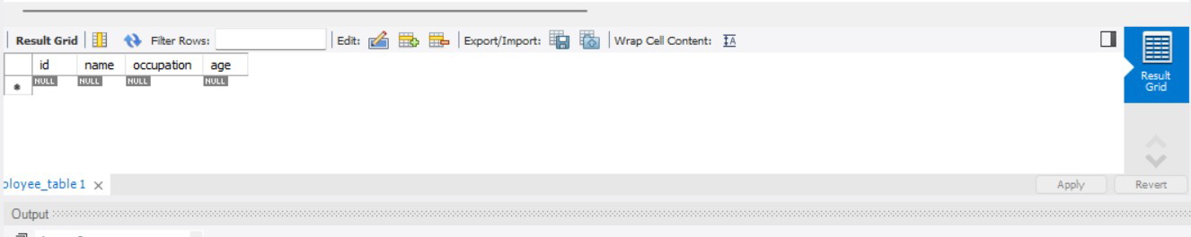

**B .DROP:** It is used to delete both the structure and record stored in the table.

### QUERY:-

DROP TABLE employee_table;

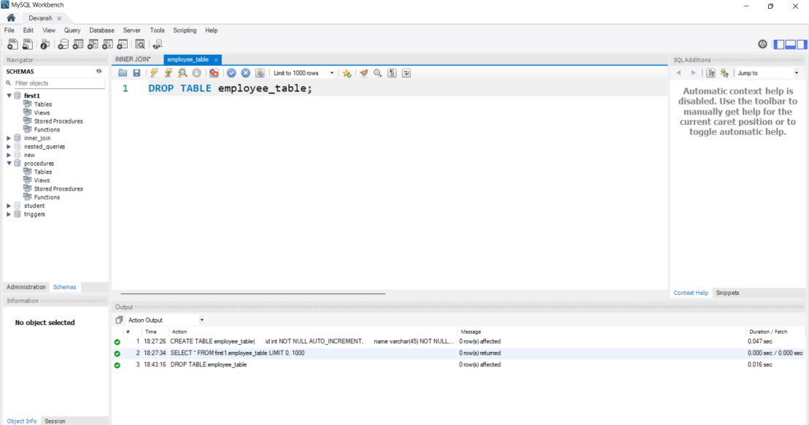

**c. ALTER :** It is used to alter the structure of the database. This change could be either to modify the characteristics of an existing attribute or probably to add a new attribute.

### QUERY:-

ALTER TABLE employee_table MODIFY occupation varchar(35) AFTER age;

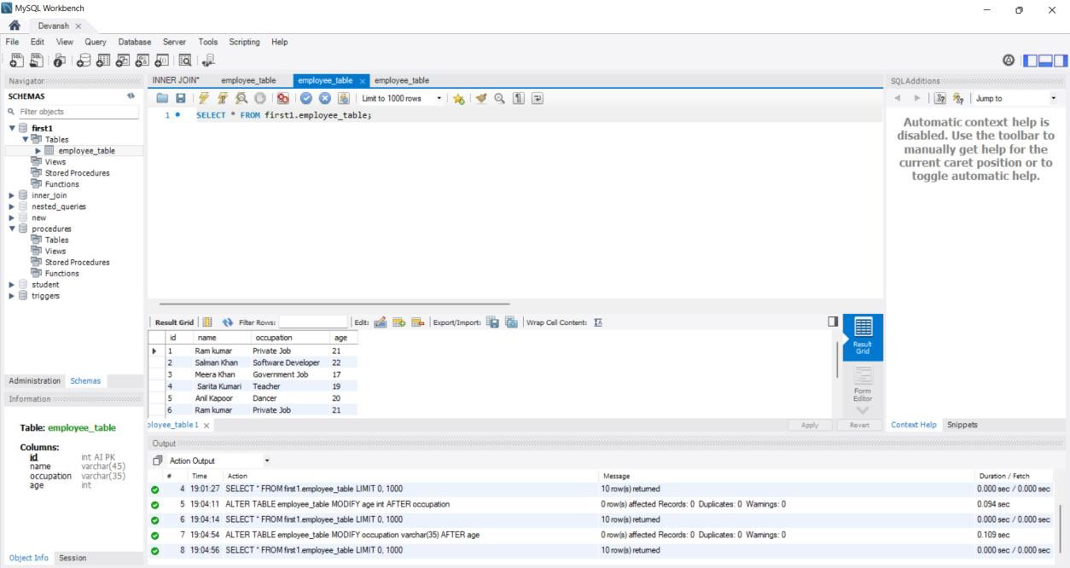

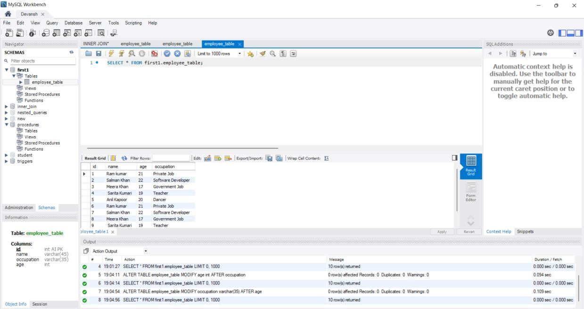

### ALTER TABLE-ADD COLUMN

**Query**:-

ALTER table employee ADD city VARCHAR(255);

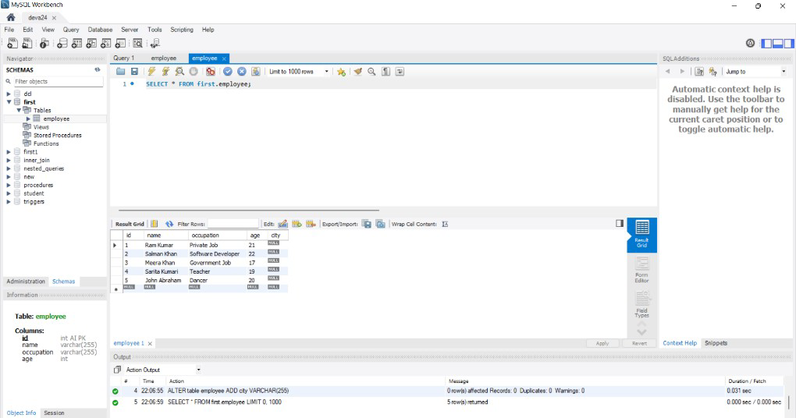

### ALTER TABLE-DROP COLUMN:-

**Query**:-

ALTER table employee DROP column occupation;

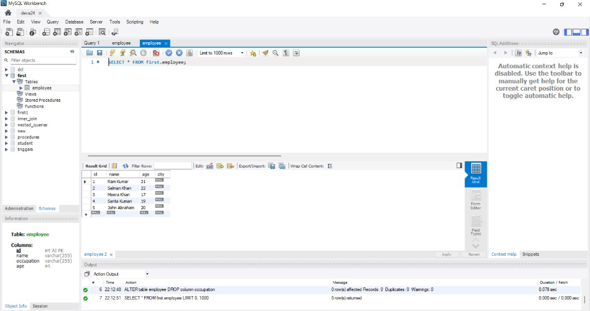

**d. TRUNCATE:** It is used to delete all the rows from the table and free the space containing the table.

### QUERY:-

TRUNCATE TABLE employee_table;



Exp No:-2 Date:-

# EXPERIMENT:-DML Commands

**Aim:-** Execute DML Commands

**Theory:-** DML commands are the most frequently used SQL commands and is used to query and manipulate the existing database objects. Some of the commands are Insert, Select, Update, Delete.

Insert Command: This is used to add one or more rows to a table. The values are separated by commas and the data types char and date are enclosed in apostrophes. The values must be entered in the same order as they are defined.

Select Command: It is used to retrieve information from the table. It is generally referred to as querying the table. We can either display all columns in a table or only specify column from the table.

Update Command: It is used to alter the column values in a table. A single column may be updated or more than one column could be updated.

Delete command: After inserting row in a table we can also delete them if required. The delete command consists of a from clause followed by an optional where clause.

PROCEDURE

STEP 1: Start

STEP 2: Create the table with its essential attributes. STEP 3: Insert the record into table

STEP 4: Update the existing records into the table STEP 5: Delete the records in to the table.

STEP 6: Select the records

### INSERT Command:-

INSERT INTO employee_table(id,name,occupation,age) VALUES

(null,'Ram kumar','Private Job',21), (null,'Salman Khan','Software Developer',22), (null,'Meera Khan','Government Job',17), (null,' Sarita Kumari','Teacher',19), (null,'Anil Kapoor','Dancer',20);

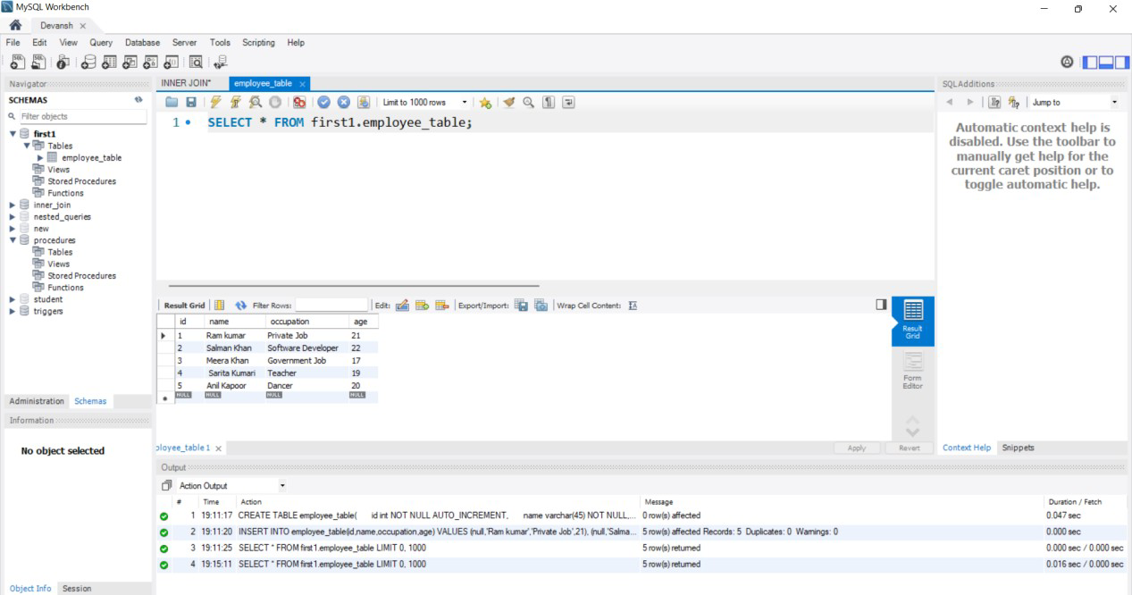

### Update Command:-

UPDATE employee_table SET occupation='Chef' WHERE id=1;

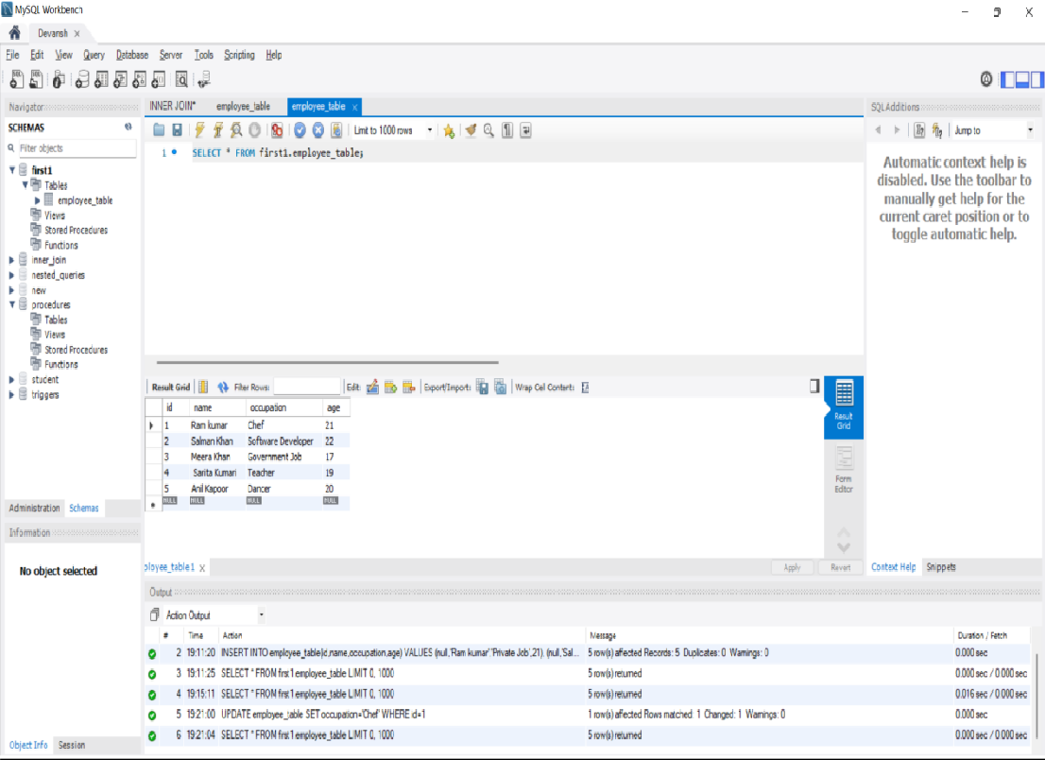

### Select Command:-

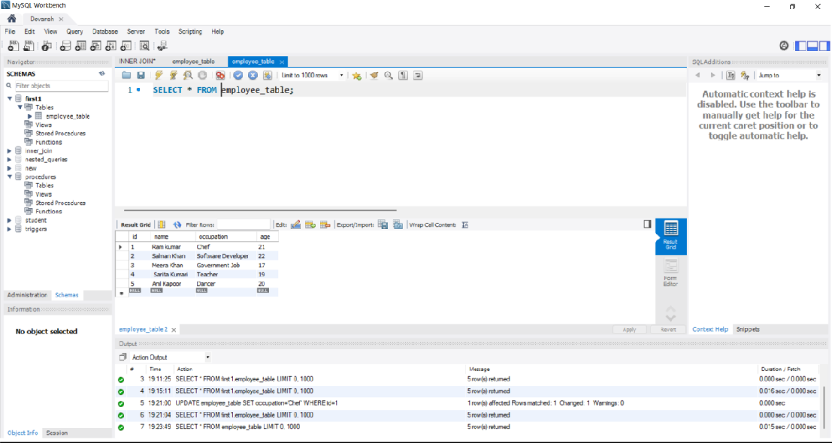

**3. Delete command:-**

DELETE FROM employee_table WHERE id=4;

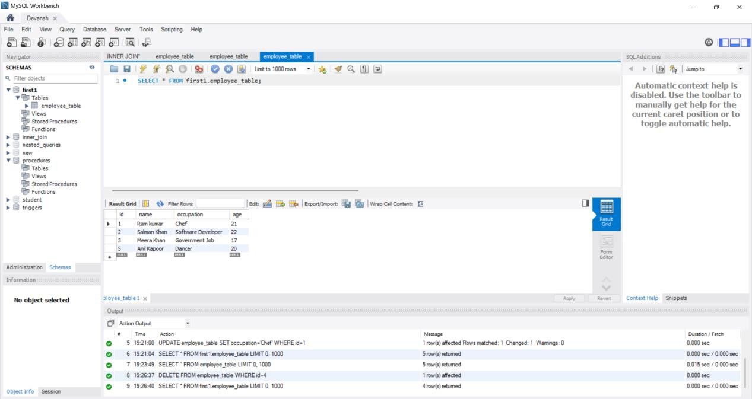

### To Implement Basic Select statements

1. **SELECT with WHERE Clause:-**

SELECT * FROM employee_table WHERE age>17;

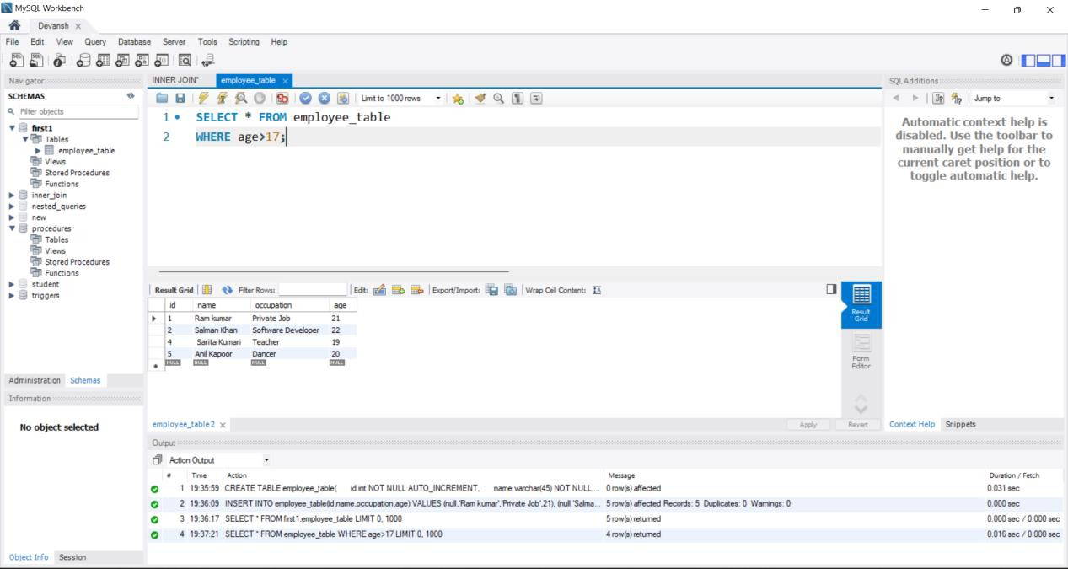

### SELECT With ORDER BY:-

SELECT * FROM employee_table WHERE age>17

ORDER BY name;

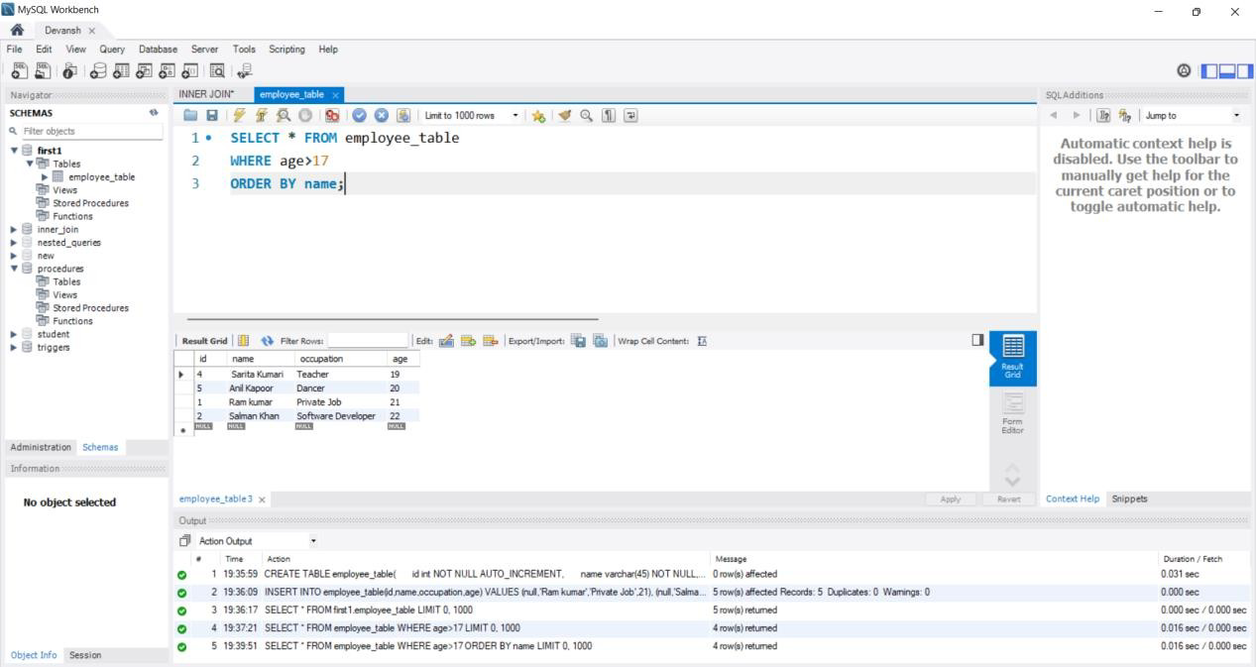

### SELECT WITH DISTINCT:-

**QUERY:-**

SELECT DISTINCT age FROM employee_table;

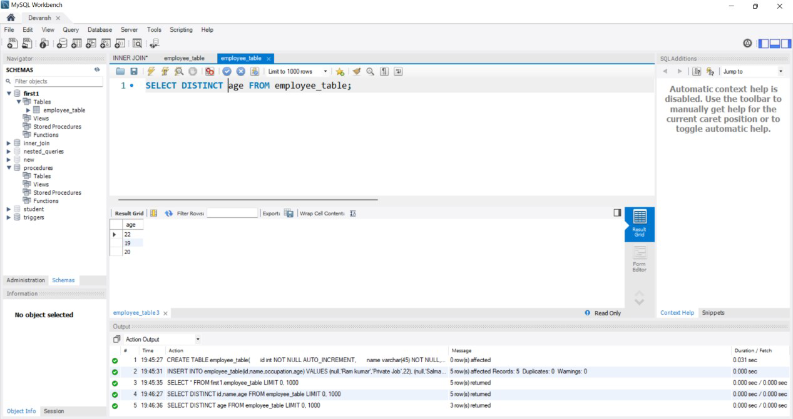

### To Execute Constraints in MySQL Theory:-

The constraint in MySQL is used to specify the rule that allows or restricts what values/data will be stored in the table. They provide a suitable method to ensure **data** accuracy and integrity inside the table. It also helps to limit the type of data that will be inserted inside the table. If any interruption occurs between the constraint and data action, the action is failed.

**QUERY**:-

CREATE TABLE employee( id INT NOT NULL UNIQUE,

name VARCHAR(50) NOT NULL,

age INT NOT NULL CHECK(age>=18), gender VARCHAR(10)NOT NULL,

city VARCHAR(10) NOT NULL DEFAULT 'Agra'

);

INSERT INTO employee(id,name,age,gender) VALUES

(1,'Akshat',21,'M'),

(2,'Rahul',22,'M'),

(3,'Devansh',18,'M'),

(4,'Amit',19,'M'),

(5,'Akash',24,'M');

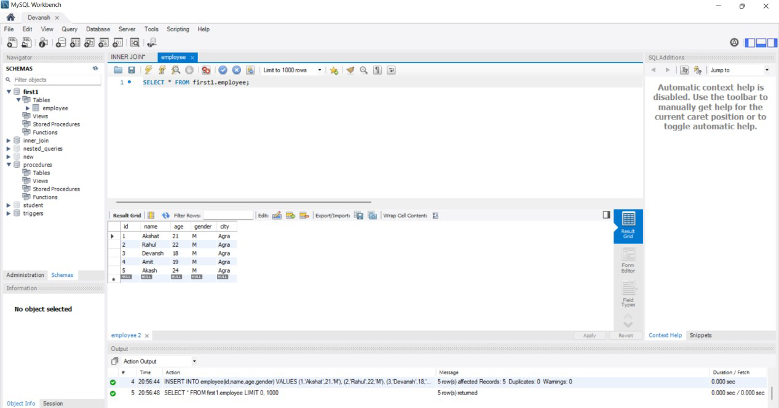

Exp No:-3 Date:-

# EXPERIMENT:-DCL Commands And TCL Commands

**Aim:-** SQL data control language and transaction control Language

**Theory:-** DCL (Data Control Language) includes commands like GRANT and REVOKE, which are useful to give “rights & permissions.” Other permission controls parameters of the database system.

### Examples of DCL commands:-

Commands that come under DCL:-

* Grant
* Revoke

### GRANT

create user admin1 identified by password1; grant create session to admin1;

grant connect to admin1;

### REVOKE

revoke create session from admin1; revoke connect from admin1; revoke create table from admin1;

### GRANT

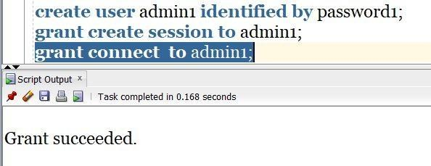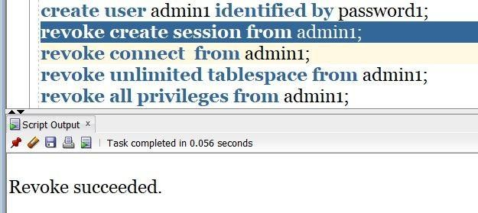

**REVOKE**

14

**TCL Commands in SQL**

* In SQL, TCL stands for Transaction control language.
* A single unit of work in a database is formed after the consecutive execution of commands is known as a transaction.
* There are certain commands present in SQL known as TCL commands that help the user manage the transactions that take place in a database.
* COMMIT**,**ROLLBACK and SAVEPOINT are the most commonly used TCL commands in SQL.

### COMMIT:-

COMMIT command in SQL is used to save all the transaction-related changes permanently to the disk. Whenever DDL commands such as INSERT, UPDATE and DELETE are used, the changes made by these commands are permanent only after closing the current session. So before closing the session, one can easily roll back the changes made by the DDL commands. Hence, if we want the changes to be saved permanently to the disk without closing the session, we will use the commit command.

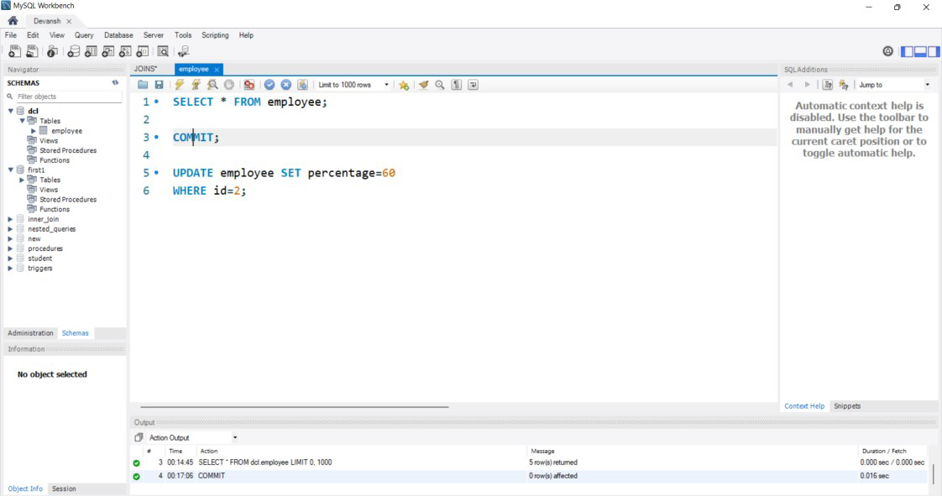

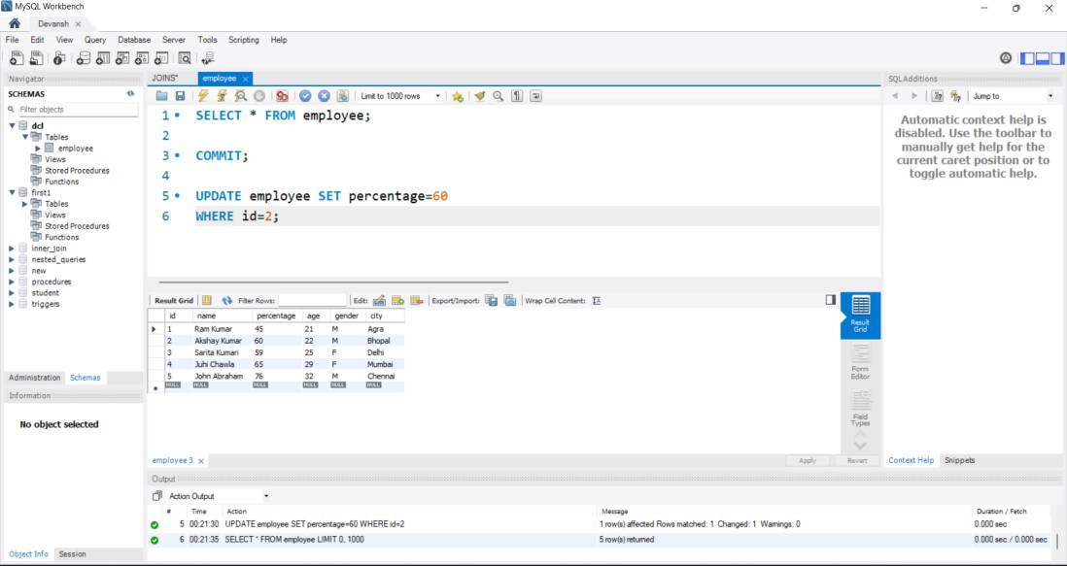

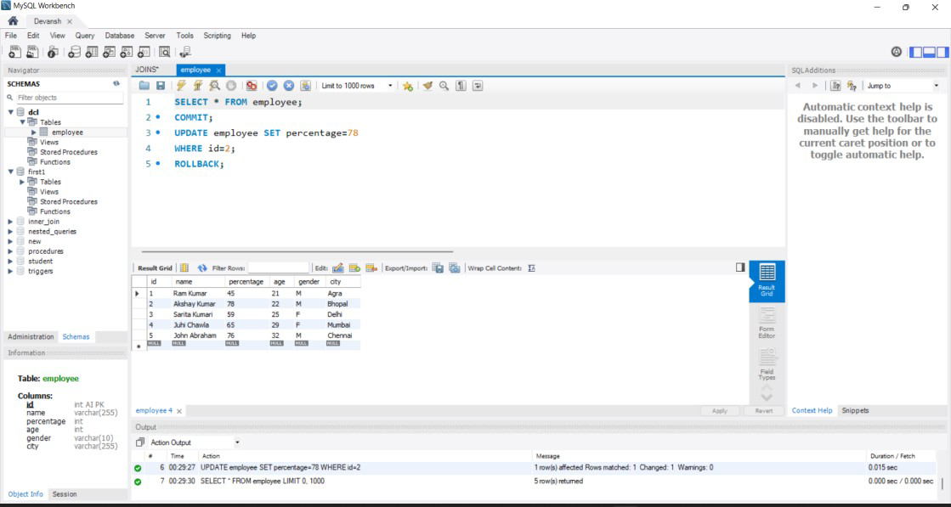

### ROLLBACK

While carrying a transaction, we must create savepoints to save different parts of the transaction. According to the user's changing requirements, he/she can roll back the transaction to different savepoints. Consider a scenario: We have initiated a transaction followed by the table creation and record insertion into the table. After inserting records, we have created a savepoint INS. Then we executed a delete query, but later we thought that mistakenly we had removed the useful record. Therefore in such situations, we have an option of rolling back our transaction. In this case, we have to roll back our transaction using the ROLLBACK command to the savepoint INS, which we have created before executing the DELETE query.

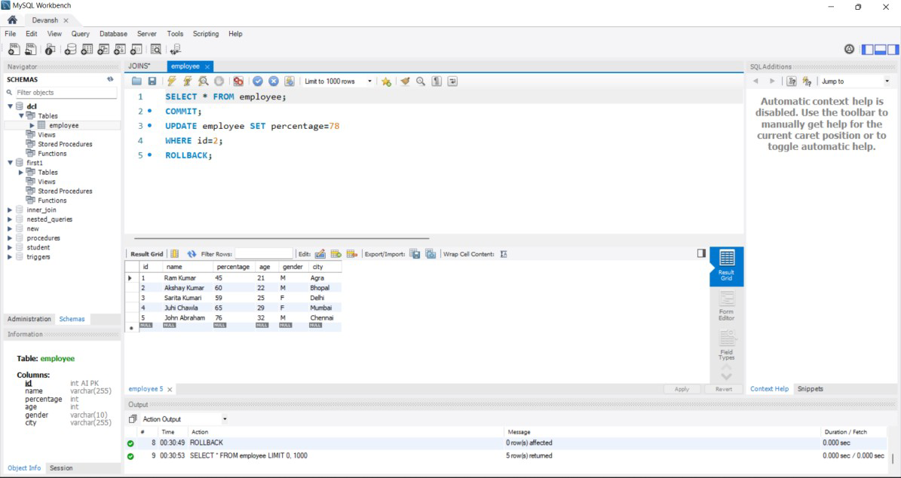

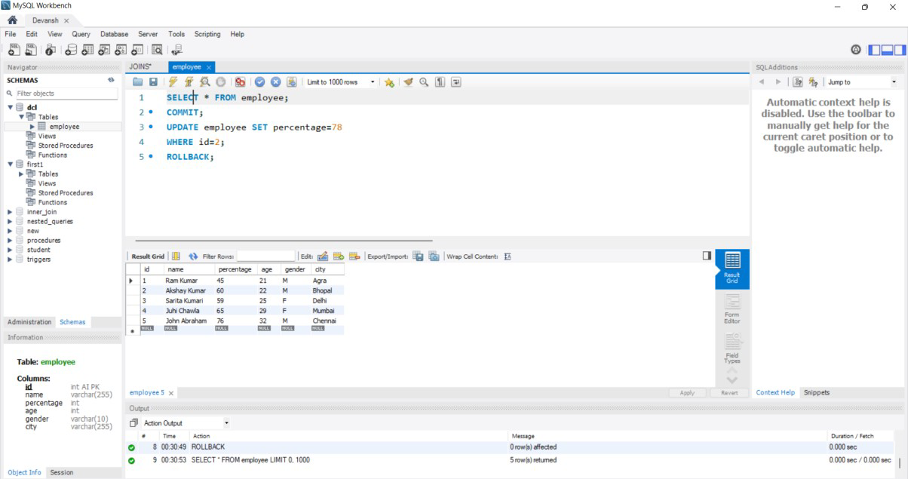

### SAVEPOINT:-

We can divide the database operations into parts. For example, we can consider all the insert related queries that we will execute consecutively as one part of the transaction and the delete command as the other part of the transaction. Using the SAVEPOINT command in SQL, we can save these different parts of the same transaction using different names. For example, we can save all the insert related queries with the savepoint named INS. To save all the insert related queries in one savepoint, we have to execute the SAVEPOINT query followed by the savepoint name after finishing the insert command execution.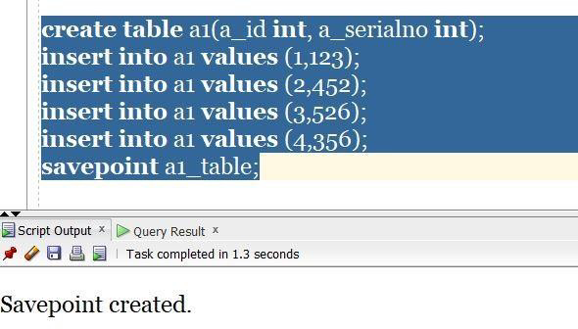

17

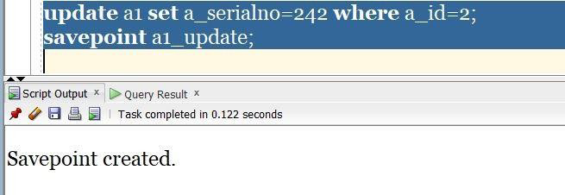

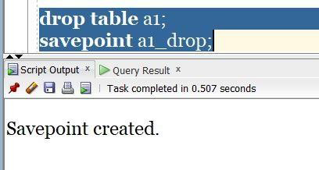

Exp No:-4 Date:-

# EXPERIMENT:-Inbuilt Functions

**Aim:-** To perform In-Built Functions In SQL.

To Execute String, Date,time function

**Theory:-** MySQL has many built-in functions.This reference contains string, numeric, date, and some advanced functions in MySQL.

1. **UPPER()**:-

SELECT id, UPPER(name) AS Name ,percentage FROM employee;

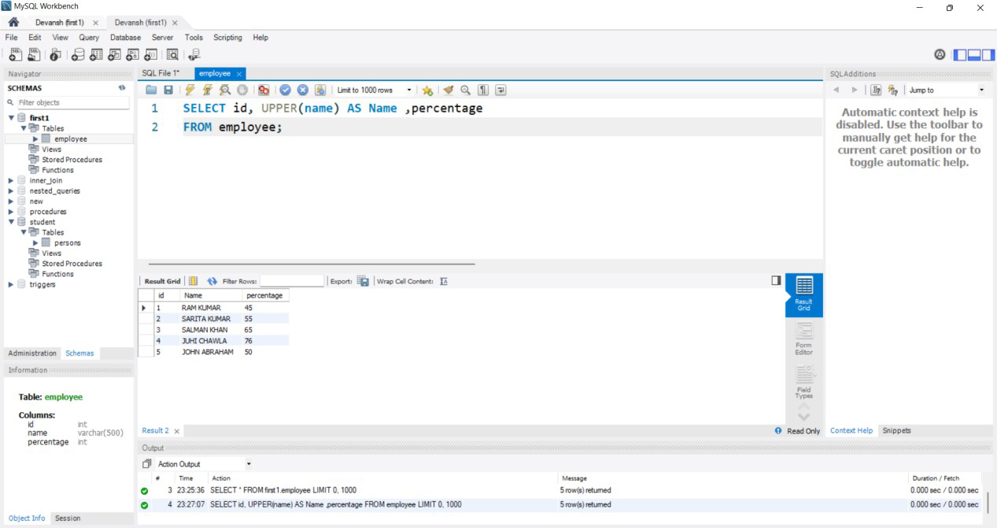

### LOWER():-

SELECT id, LOWER(name) AS Name ,percentage FROM employee;

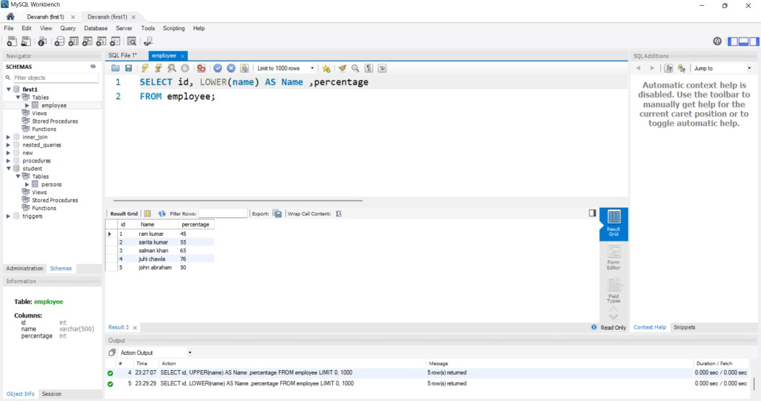

### CHARACTER_LENGTH():-

**QUERY:-**

SELECT id,NAME, character_length(name)AS "CHARACTER LENGTH" ,percentage

FROM employee;

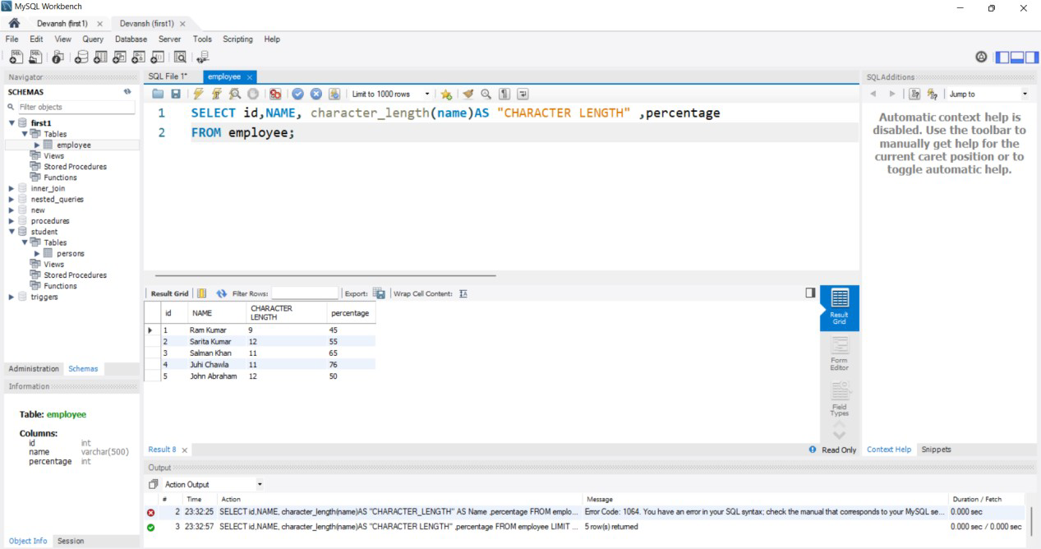

### CONCAT():-

**QUERY:-**

SELECT id,NAME, CONCAT(name ,percentage) AS CONCAT FROM employee;

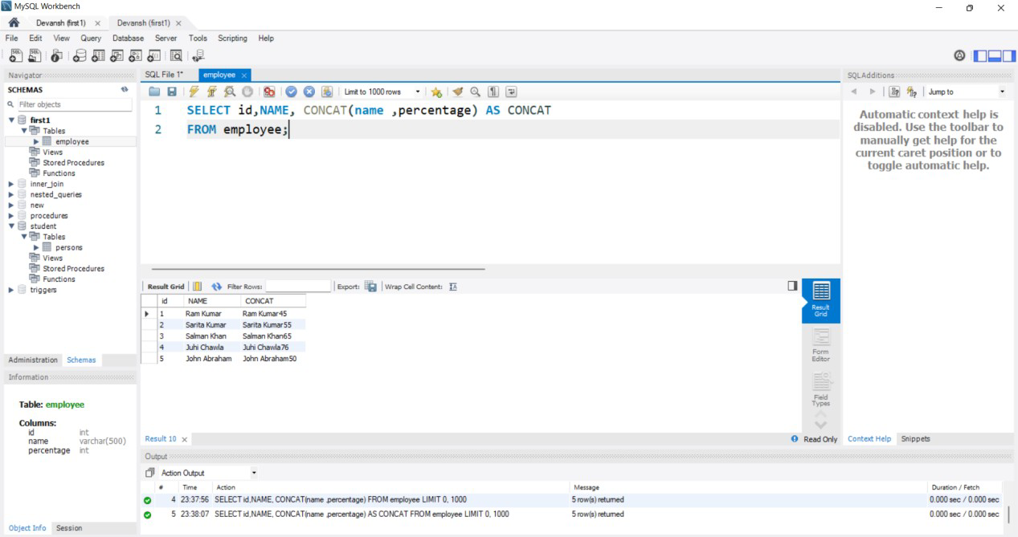

### DATE AND TIME FUNCTIONS:-

**1.CURRENT_DATE():-**

### QUERY:-

SELECT CURRENT_DATE();

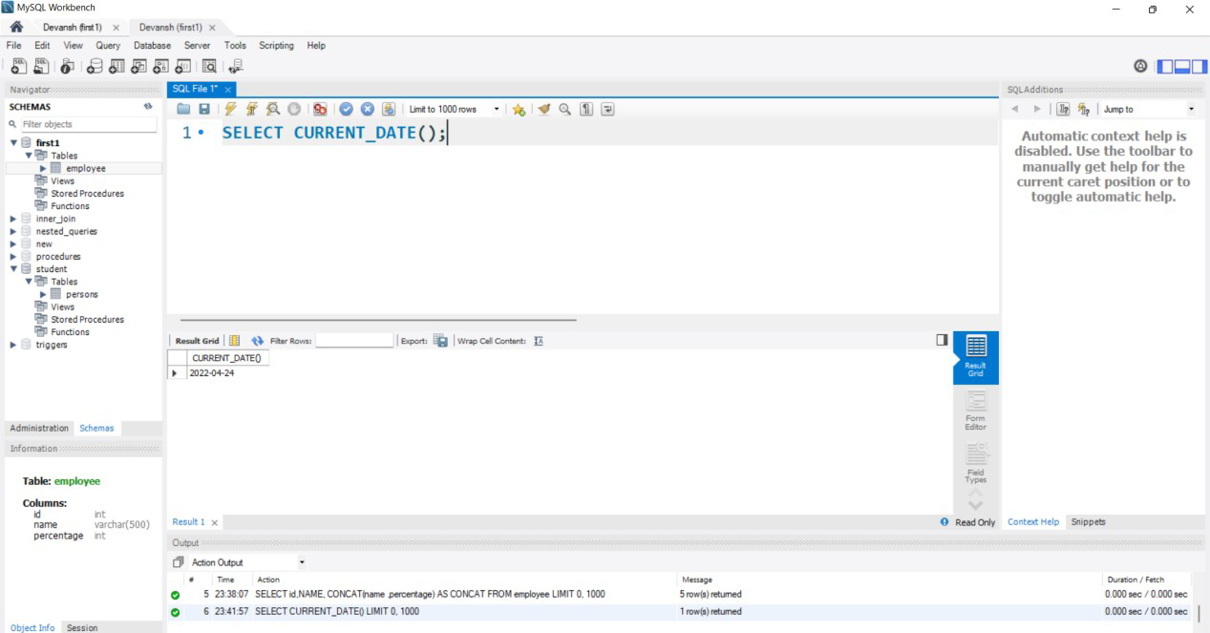

### 2. NOW():-

**QUERY:-**

SELECT NOW();

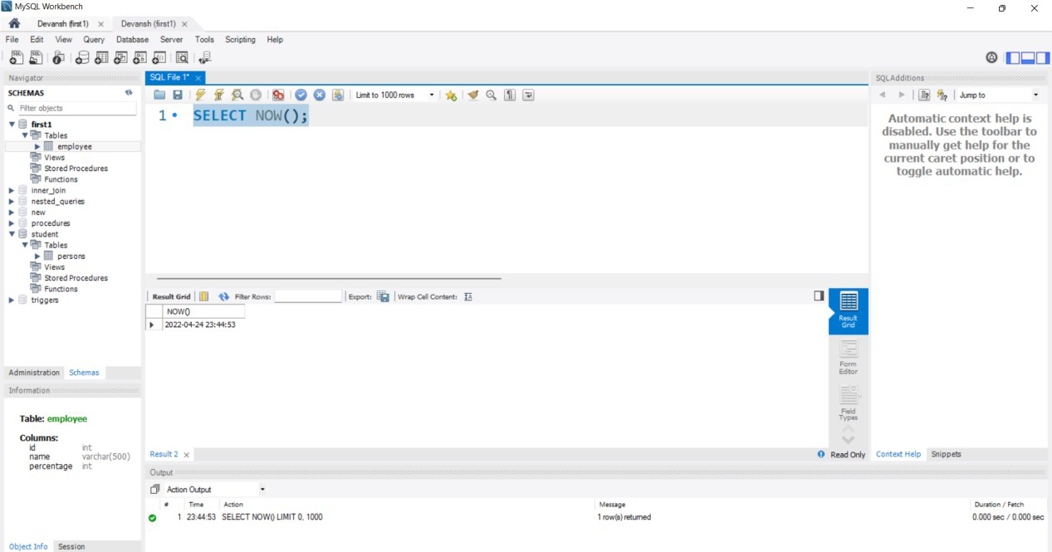

### 3 DATE():- QUERY:-

SELECT DATE("2022-04-24 23:48:15");

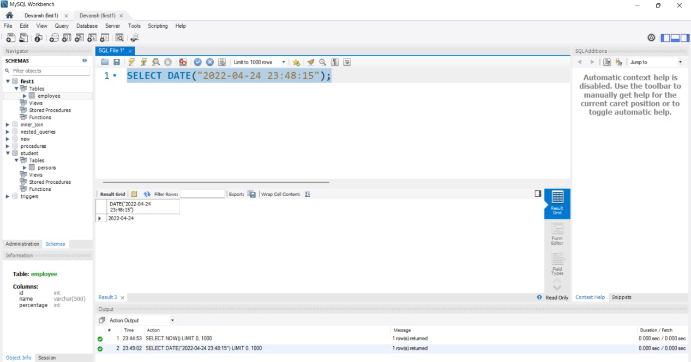

### TIME FUNCTIONS:-

**1.Current_time():-**

### QUERY:-

SELECT current_time();

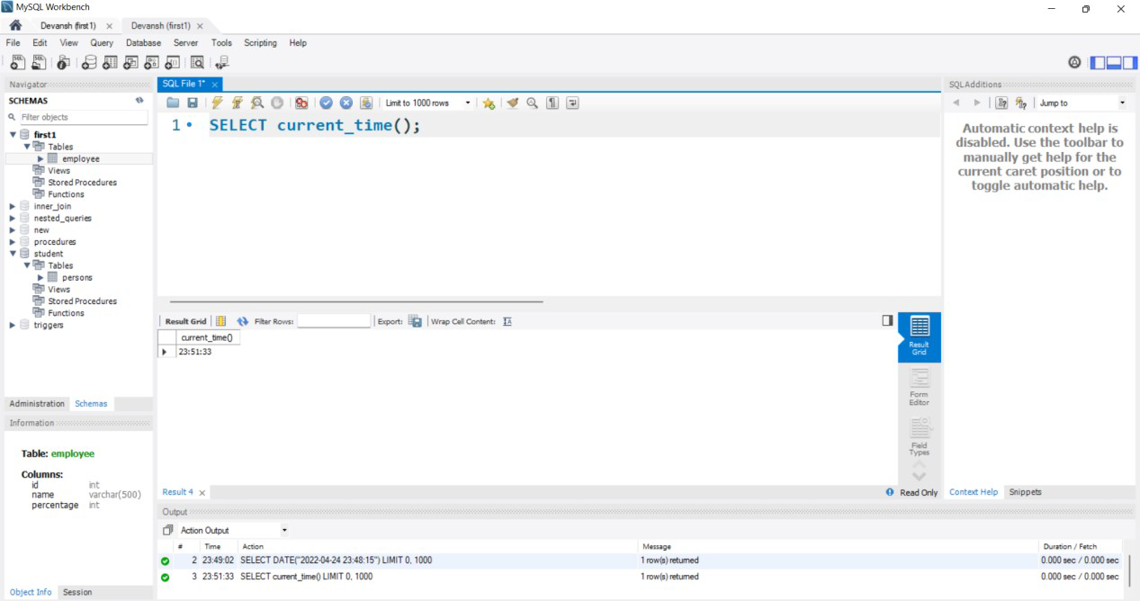

### 2 Current_timestamp():-

**QUERY:-**

SELECT current_timestamp();

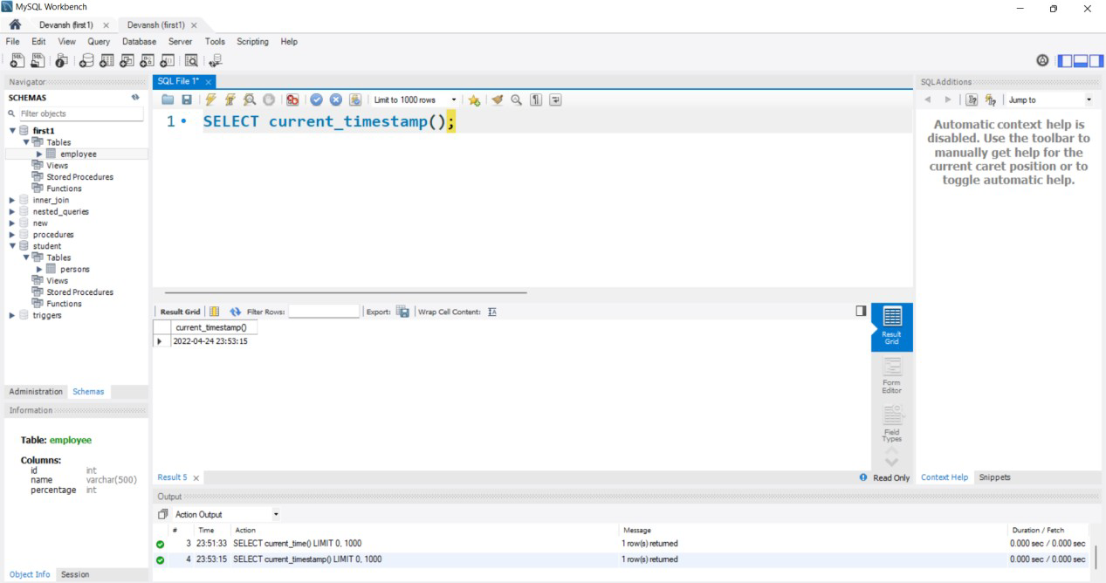

### 3. localtime():-

**QUERY:-**

SELECT localtime();

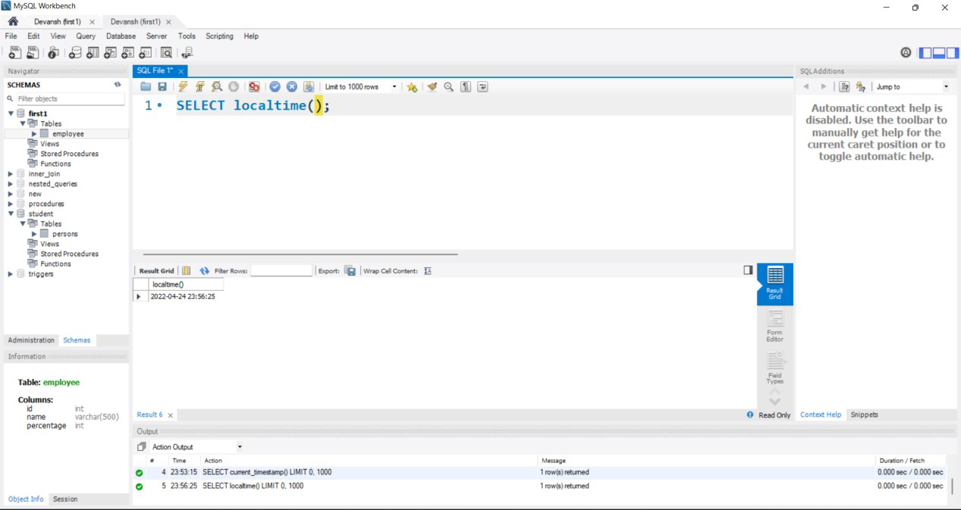

### To Execute Aggregate Functions.

**Theory:-**SQL aggregation function is used to perform the calculations on multiple rows of a single column of a table. It returns a single value.It is also used to summarize the data.

### COUNT FUNCTION:-

COUNT function is used to Count the number of rows in a database table. It can work on both numeric and non-numeric data types.

### QUERY:-

SELECT COUNT(name) FROM employee_table;

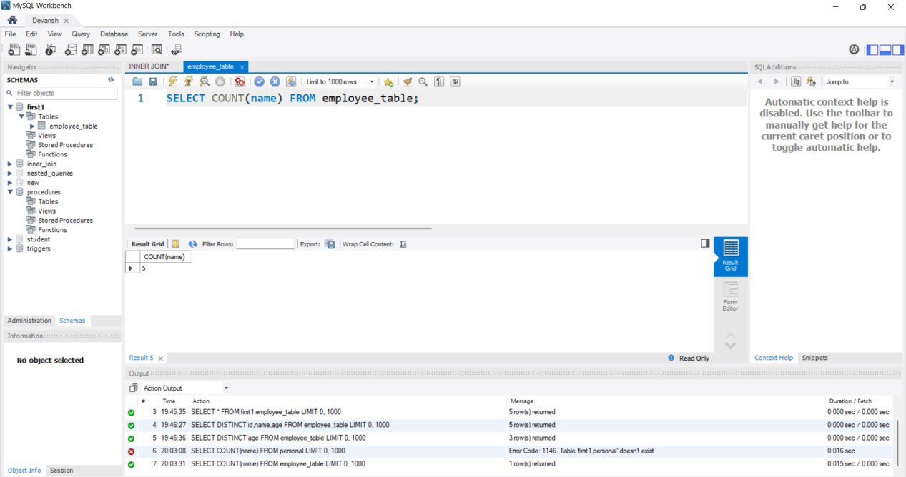

### SUM Function:-

Sum function is used to calculate the sum of all selected columns. It works on numeric fields only.

### QUERY:-

SELECT SUM(percentage) FROM employee_table;

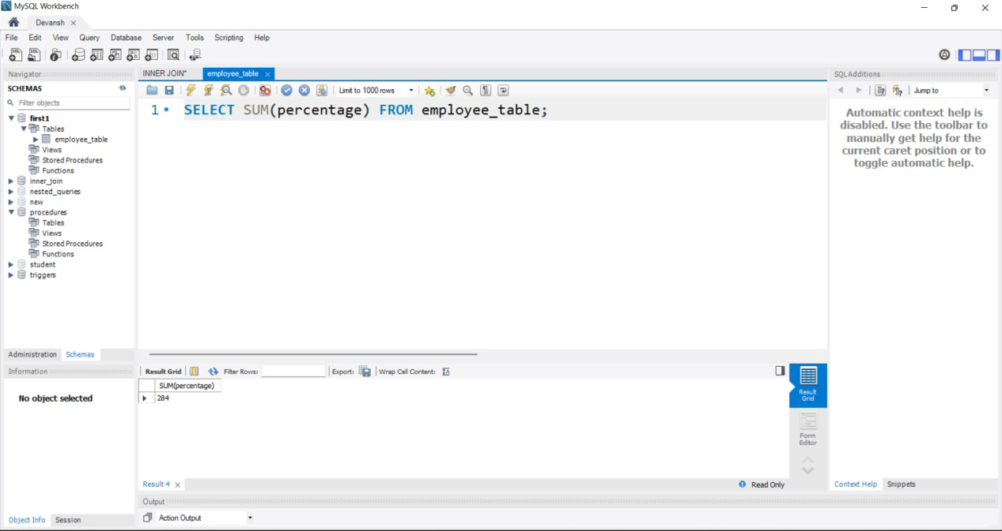

### AVG function:-

The AVG function is used to calculate the average value of the numeric type.

### QUERY:-

SELECT AVG(percentage) FROM employee_table;

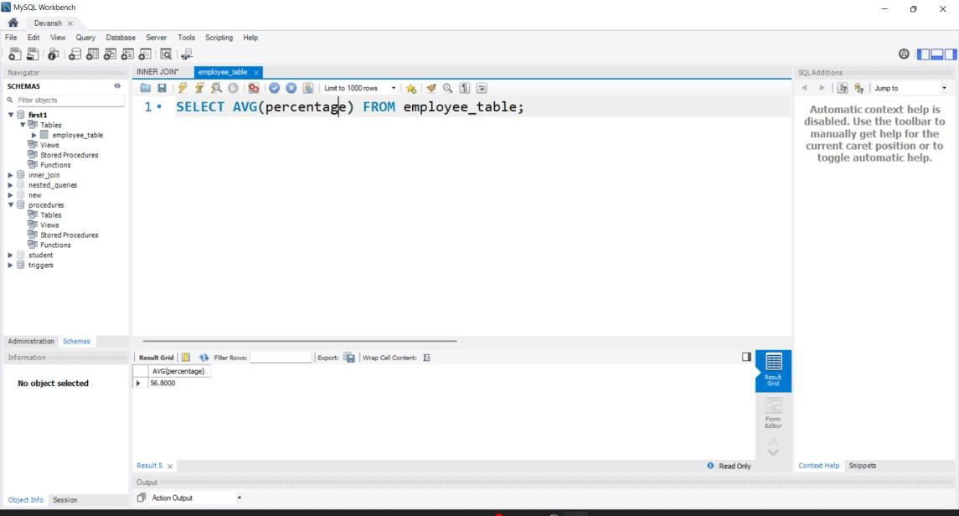

### MAX Function:-

MAX function is used to find the maximum value of a certain column. This function determines the largest value of all selected values of a column.

### QUERY:-

SELECT MAX(percentage) FROM employee;

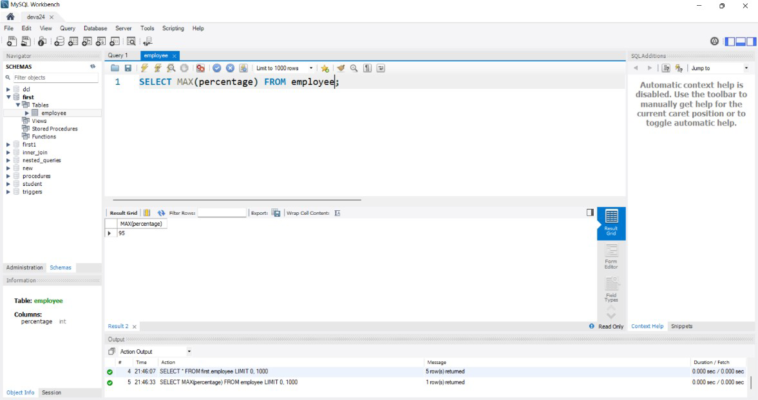

### MIN Function:-

MIN function is used to find the minimum value of a certain column. This function determines the smallest value of all selected values of a column.

**QUERY**:-

SELECT MIN(percentage) FROM employee_table;

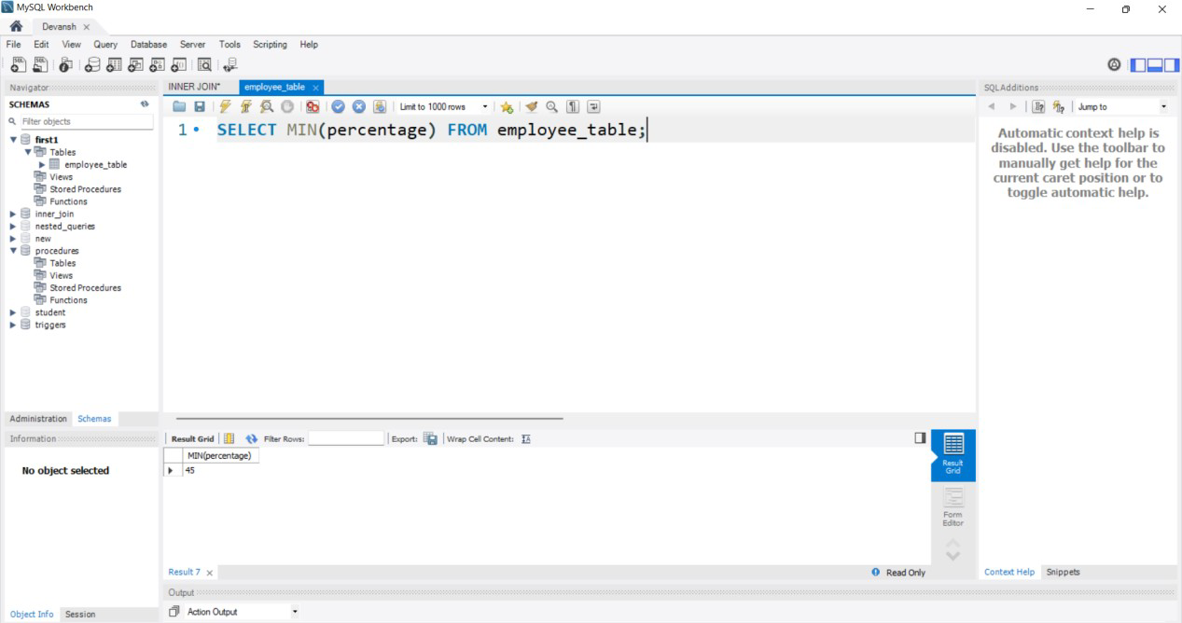

Exp No:-5 Date:-

**Col_Id**

**Col_Name**

**College**

**EXPERIMENT:-ER Model**

**Aim:-**Construct a e- r model for the application to be constructed to a Database:

* 1. E-R model for Property Management Database Project
  2. E-R model for Water Supply Management System
  3. E-R model for Home renting system database
  4. E-R model for Complaint management system database
  5. E-R model for Employee performance review system database
  6. E-R model for Employee track and report system database

**Theory:-** ER model stands for an Entity-Relationship model. It is a high-level data model. This model is used to define the data elements and relationship for a specified system.It develops a conceptual design for the database. It also develops a very simple and easy to design view of data.In ER modeling, the database structure is portrayed as a diagram called an entity-relationship diagram.

**Stu_Name**

**Stu_Id**

**Stu_addr**

**Study**

**In**

**Student**

Exp No:-6 Date:-

**EXPERIMENT:-Nested Queries**

**Aim:-** To Execute Subqueries

**Theory:-**A subquery in MySQL is a query, which is nested into another SQL query and embedded with SELECT, INSERT, UPDATE or DELETE statement along with the various operators. We can also nest the subquery with another subquery. A subquery is known as the inner query, and the query that contains subquery is known as the outer query. The inner query executed first gives the result to the outer query, and then the main/outer query will be performed. [MySQL](https://www.javatpoint.com/mysql-tutorial) allows us to use subquery anywhere, but it must be closed within parenthesis. All subquery forms and operations supported by the SQL standard will be supported in MySQL also.

### QUERY:-

CREATE TABLE department( dept_id INT PRIMARY KEY, dept_name VARCHAR(50)

);

INSERT INTO department VALUES

(1,'H-R'),

(2,'Finance'),

(3,'Accounts'), (4,'Administration'), (5,'Counselling');

CREATE TABLE employee( emp_id INT PRIMARY KEY, name VARCHAR(500),

gender VARCHAR(50), age INT,

salary INT, dept_id INT,

FOREIGN KEY(dept_id) REFERENCES department(dept_id)

);

INSERT INTO employee VALUES (1,'Ali','M',23,24000,3),

(2,'Anup','M',24,25000,4),

(3,'Akshay','M',22,22000,1),

(4,'Akshat','M',21,65000,2),

(5,'Rahul','M',23, 22000,4);

-- THIS IS NESTED QUERY--

SELECT * from employee

WHERE dept_id =(SELECT dept_id FROM department WHERE dept_name='H-R');

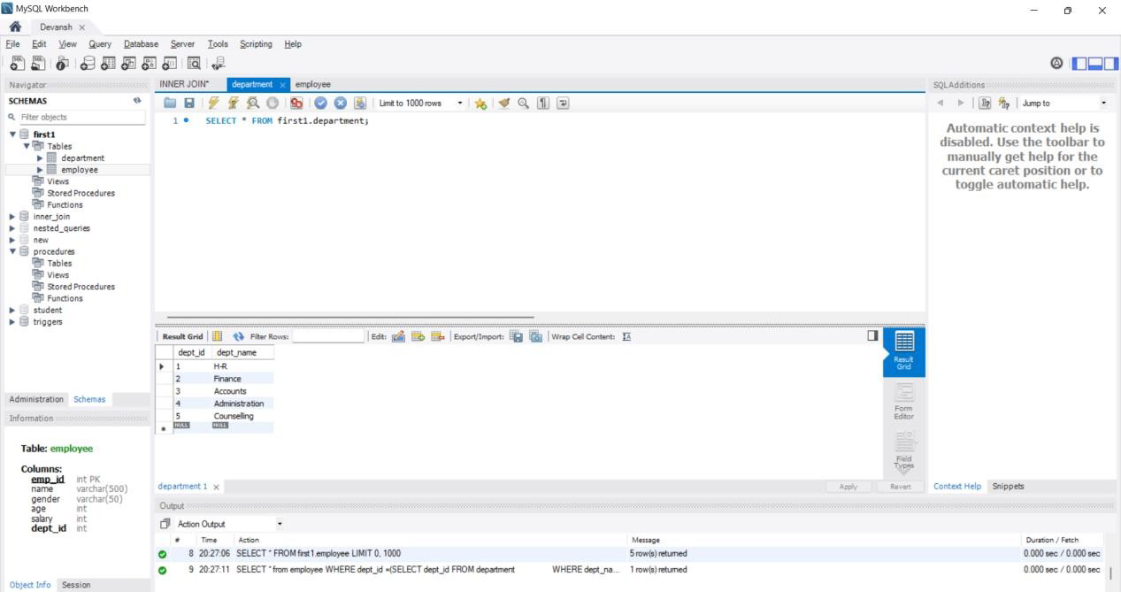

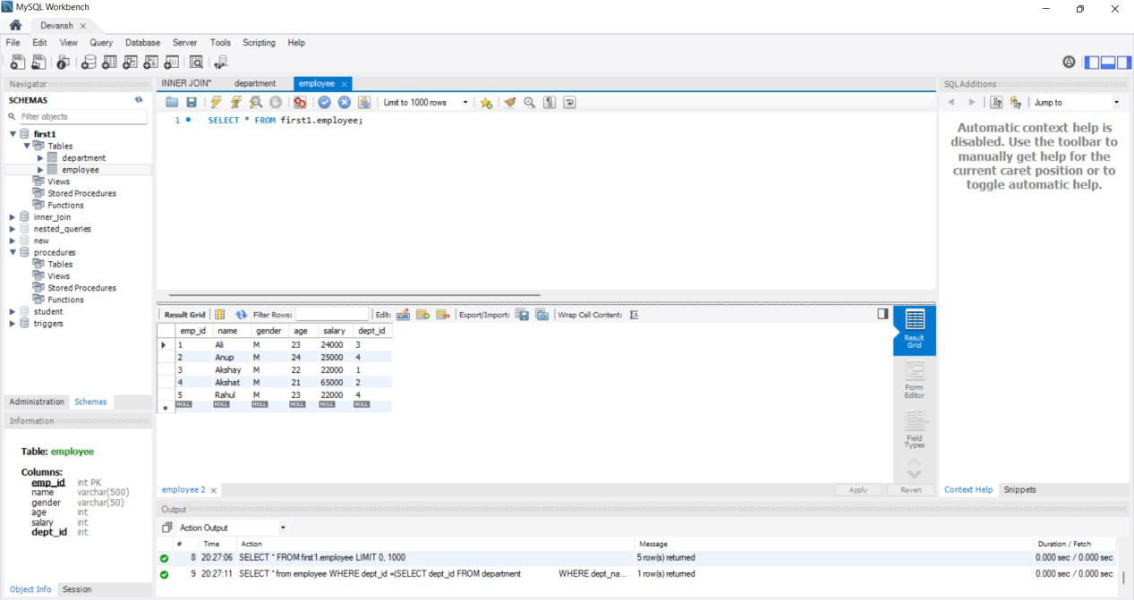

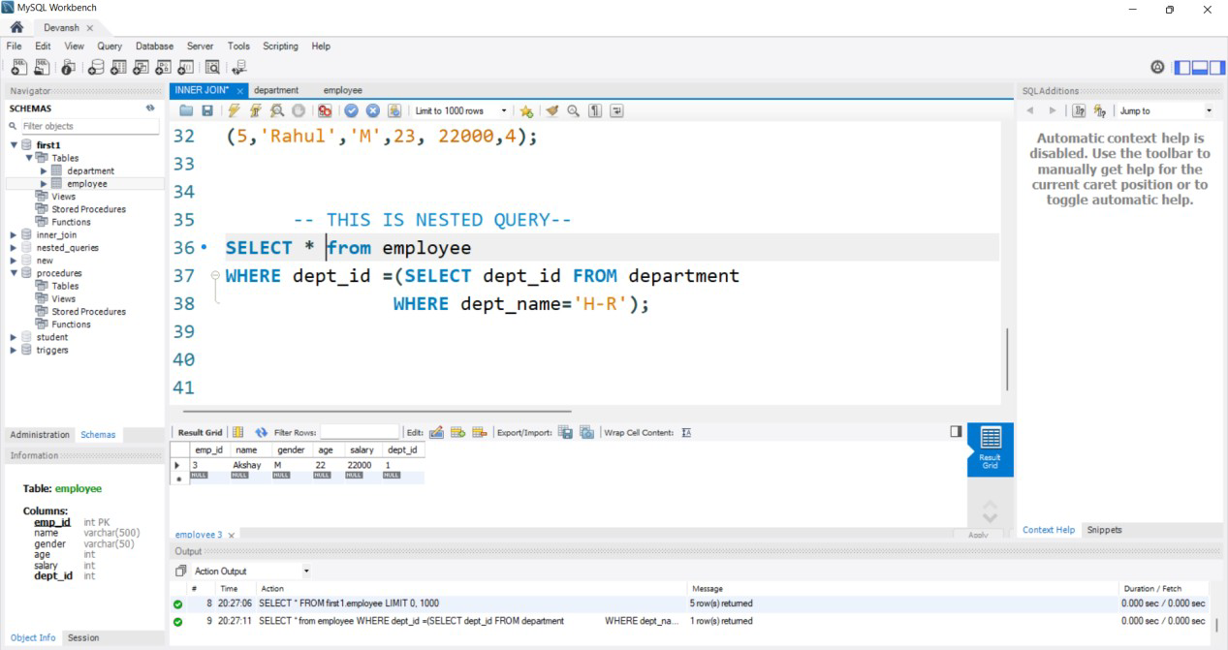

### Subqueries:-

**CREATING TABLE FOR SUBQUERY**

CREATE TABLE department( id INT primary key,

name varchar(100) NOT NULL, gender varchar(50) NOT NULL, city varchar(20) NOT NULL, salary int NOT NULL

);

INSERT INTO department(id,name,gender,city,salary) VALUES

(1,'Ram Kumar','M','Rajasthan',12000),

(2,'Neeraj Singh','M','MP',15000),

(3,'Devansh Sharma','M','Delhi',30000),

(4,'Rahul Kalia','M','UP',40000),

(5,'Akshat Jain','M','UP',50000);

### QUERY 1:-

SELECT * from department where id

IN(SELECT id from department where salary>12000);

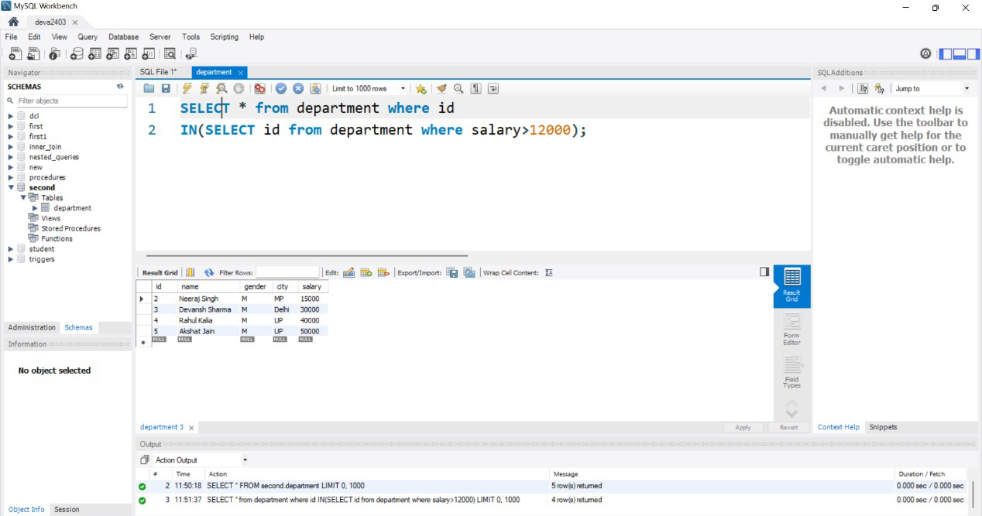

### QUERY 1:-

SELECT * from department where salary> (SELECT AVG(salary) from department);

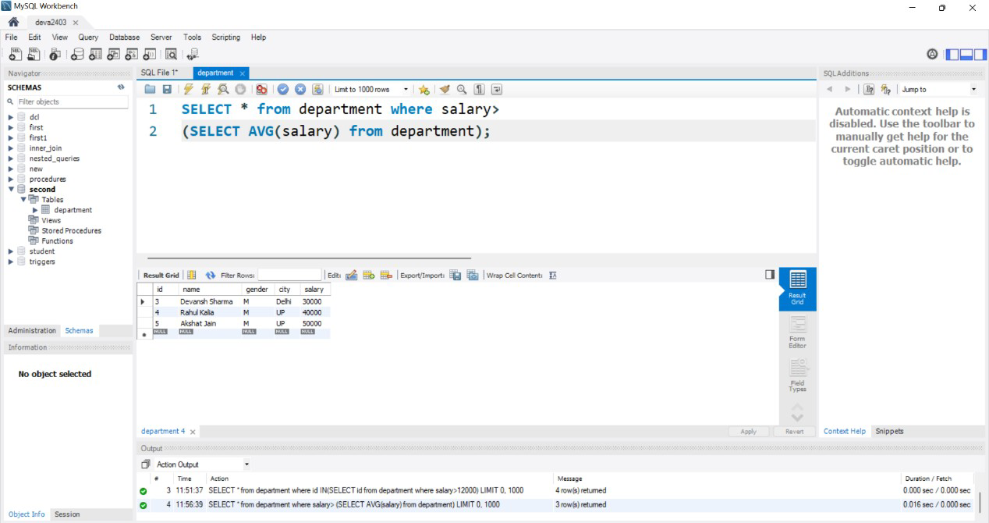

### Find the name and salary of the employee with maximum salary:-

**CREATING TABLE**

CREATE TABLE department( id INT,

name varchar(100), gender varchar(50), city varchar(20), salary int

);

INSERT INTO department(id,name,gender,city,salary) VALUES

(1,'Ram Kumar','M','Rajasthan',12000),

(2,'Neeraj Singh','M','MP',15000),

(3,'Devansh Sharma','M','Delhi',30000),

(4,'Rahul Kalia','M','UP',40000),

(5,'Akshat Jain','M','UP',50000);

### QUERY:-

SELECT * from department where id IN(SELECT max(salary) from department);

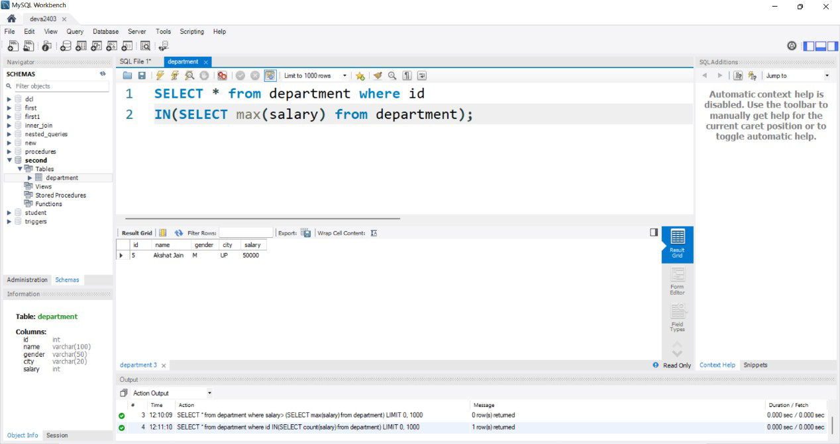

### Find the count of employees for each job so that at least two of the employees had salary greater than 10000:-

**QUERY:-**

SELECT count(name) AS COUNT from department

where name=(select count(salary)>10000 from department)

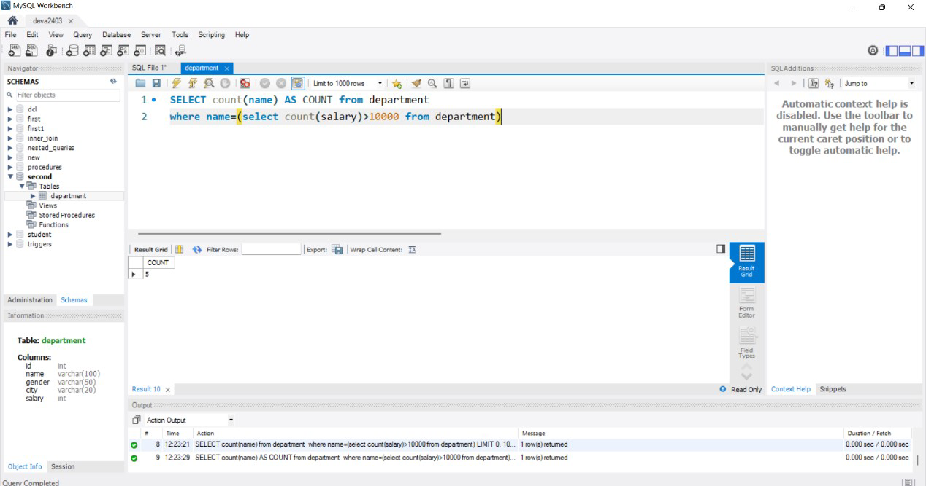

Exp No:-7 Date:-

# EXPERIMENT:-Join Queries

**Aim:-**To Execute Joins in MySQL

### Theory:-

MySQL JOINS are used with SELECT statement. It is used to retrieve data from multiple tables. It is performed whenever you need to fetch records from two or more tables.

There are three types of [MySQL](https://www.javatpoint.com/mysql-tutorial) joins:

* MySQL INNER JOIN (or sometimes called simple join)
* MySQL LEFT OUTER JOIN (or sometimes called LEFT JOIN)
* MySQL RIGHT OUTER JOIN (or sometimes called RIGHT JOIN)

### MySQL Inner JOIN (Simple Join):-

The [MySQL INNER JOIN](https://www.javatpoint.com/mysql-inner-join) is used to return all rows from multiple tables where the join condition is satisfied. It is the most common type of join.

### QUERY:-

CREATE TABLE teacher( t_id int primary key,

name varchar(50) not null, qualification varchar(50) not null, salary int not null

);

INSERT INTO teacher VALUES (1,'Akshay','MCS',12000),

(2,'Amit','MBA',14000),

(3,'Aditya','MSC',13000),

(4,'Akshat','BSIT',15000),

(5,'Rahul','MPHIL',16000);

CREATE TABLE student( s_id int primary key,

name varchar(50) not null, class int not null,

t_id int not null

);

INSERT INTO student VALUES (1,'Noman',11,2),

(2,'Asghar',12,4),

(3,'Furqan',10,2),

(4,'Khurram',11,1),

(5,'Asad',12,5),

(6,'Anees',10,1),

(7,'Khalid',11,2);

### -- INNER JOIN QUERY--

SELECT t.t_id,t.name,t.qualification,s.name,s.class FROM teacher t

INNER JOIN student s ON t.t_id= s.t_id ORDER BY t_id,t.name;

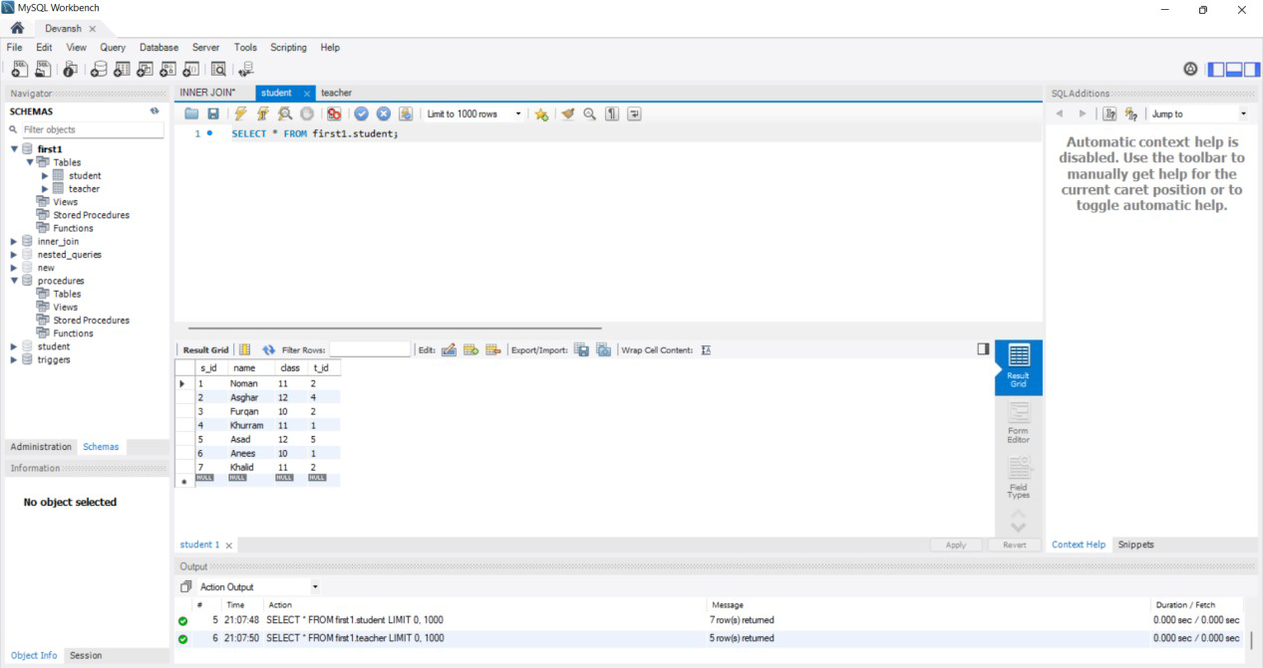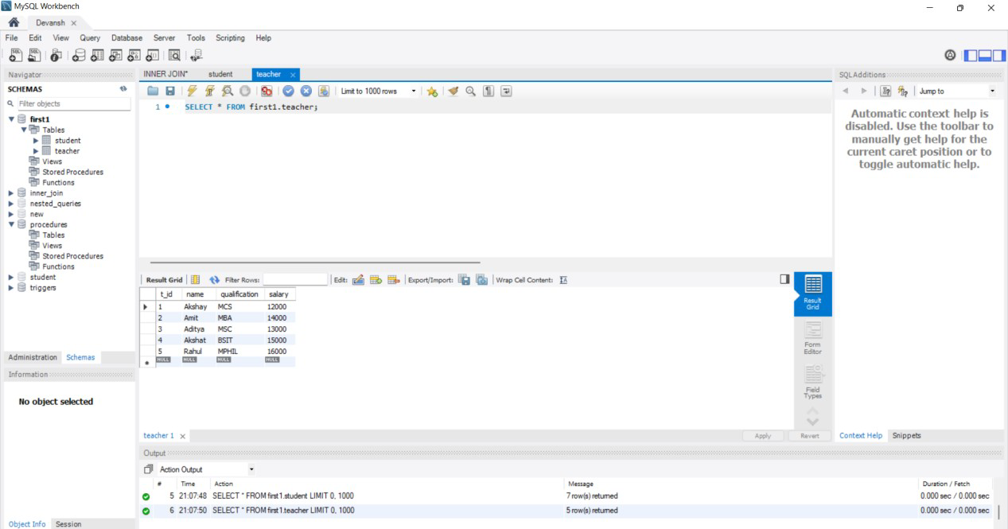

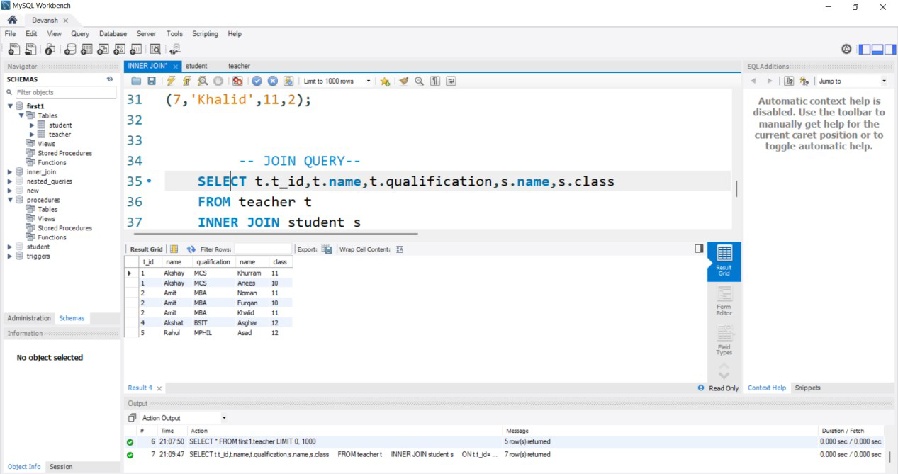

### MySQL Left Outer Join:-

The LEFT OUTER JOIN returns all rows from the left hand table specified in the ON condition and only those rows from the other table where the join condition is fulfilled.

### QUERY:-

CREATE TABLE city(

cid INT NOT NULL AUTO_INCREMENT, cityname VARCHAR(50) NOT NULL, PRIMARY KEY(cid)

);

INSERT INTO city(cityname) VALUES

('Agra'),

('Delhi'),

('Bhopal'),

('Jaipur'),

('Noida');

CREATE TABLE personal( id INT NOT NULL,

name VARCHAR(50) NOT NULL,

percentage INT NOT NULL, age INT NOT NULL,

gender VARCHAR(1) NOT NULL, city INT NOT NULL,

PRIMARY KEY(id),

FOREIGN KEY(city) REFERENCES City(cid)

);

INSERT INTO personal(id,name,percentage,age,gender,city) VALUES

(1,'Ram Kumar',45,19,"M",1),

(2,'Sarita Kumari',55,22,"M",2),

(3,'Salman Khan',62,20,"M",1),

(4,'Juhi Chawla',41,18,"M",3),

(5,'Anil Kaapoor',74,22,"M",1),

(6,'John Abraham',64,21,"M",2),

(7,'Shahid Kapoor',52,20,"M",1);

SELECT * FROM personal LEFT JOIN city

ON personal.city=city.cid;

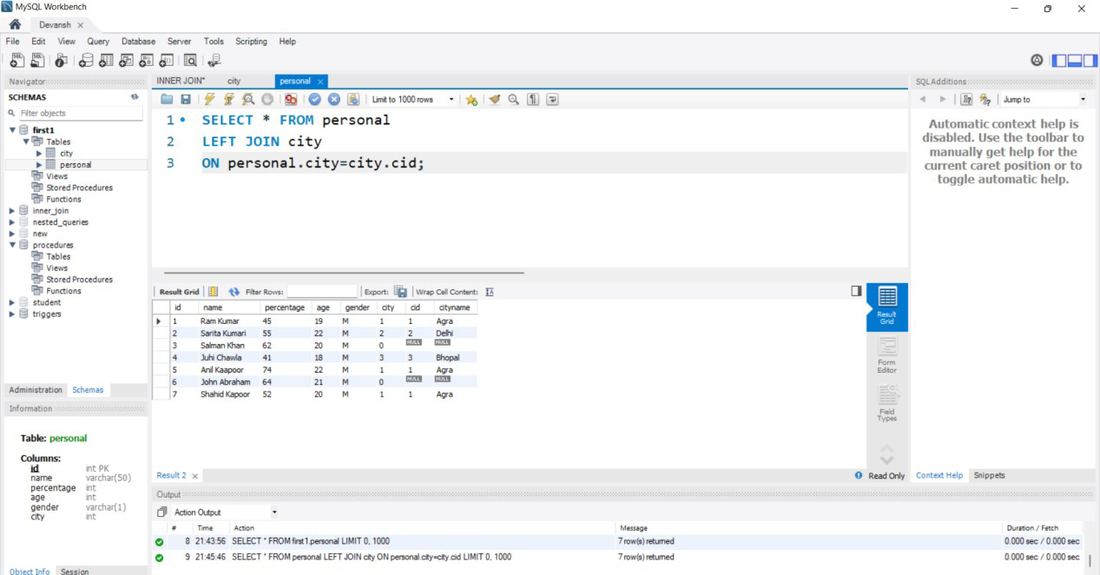

### MySQL Right Outer Join:-

The MySQL Right Outer Join returns all rows from the RIGHT-hand table specified in the ON condition and only those rows from the other table where he join condition is fulfilled.

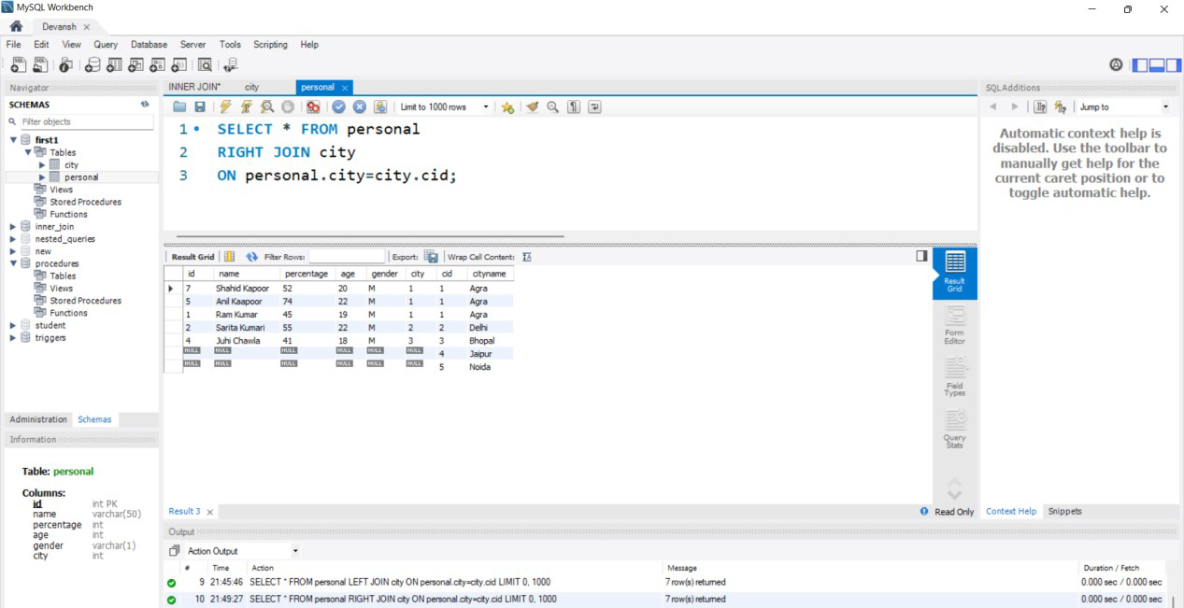

### SQL FULL OUTER JOIN Keyword:-

The FULL OUTER JOIN keyword returns all records when there is a match in left (table1) or right (table2) table records.

### QUERY:-

SELECT * FROM personal LEFT JOIN city

ON personal.city=city.cid UNION SELECT * FROM personal RIGHT JOIN city

ON personal.city=city.cid;

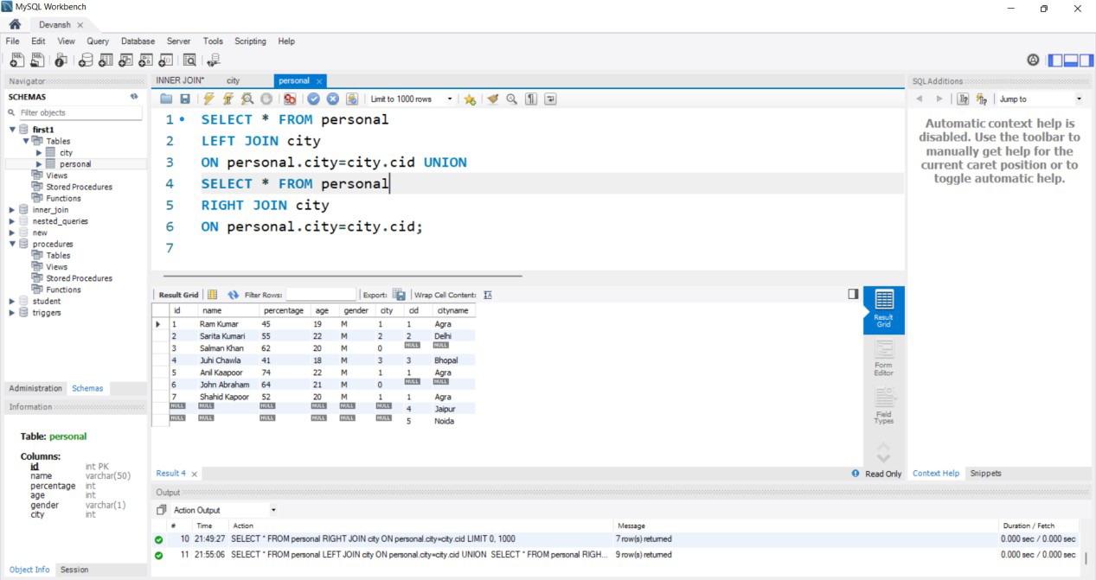

### SQL CROSS JOIN Keyword

The CROSS JOIN keyword returns all records from both tables (table1 and table2).

### QUERY:-

SELECT * FROM student CROSS JOIN City;

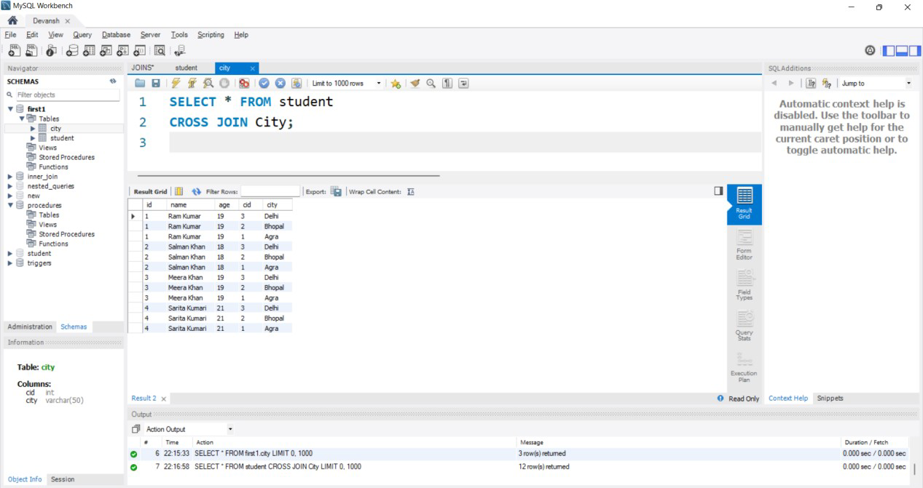

Exp No:-8 Date:-

# EXPERIMENT:-Set Operators & Views

**Aim:-** To execute Set Operators and Views in Mysql

**Theory:-** SQL supports few Set operations which can be performed on the table data. These are used to get meaningful results from data stored in the table, under different special conditions.

### SET OPERATORS:-

1. Union
2. Union all
3. Intersect
4. Minus

### CREATING TABLES FOR SET OPERATORS(UNION and UNION ALL):-

CREATE TABLE student1( id INT,

name VARCHAR(255),

age INT

);

INSERT INTO student1(id,name,age) VALUES

(1,'Devansh Sharma',21),

(2,'Rahul Kalia',26),

(3,'Akshat Jain',34);

CREATE TABLE students( id INT,

name VARCHAR(255),

age INT

);

INSERT INTO students(id,name,age) VALUES

(1,'Devansh Sharma',21),

(2,'Sarita Kumari',26),

(3,'Rohan Dubey',34);

### Union:- Query:-

SELECT *from student1 UNION

SELECT * from students

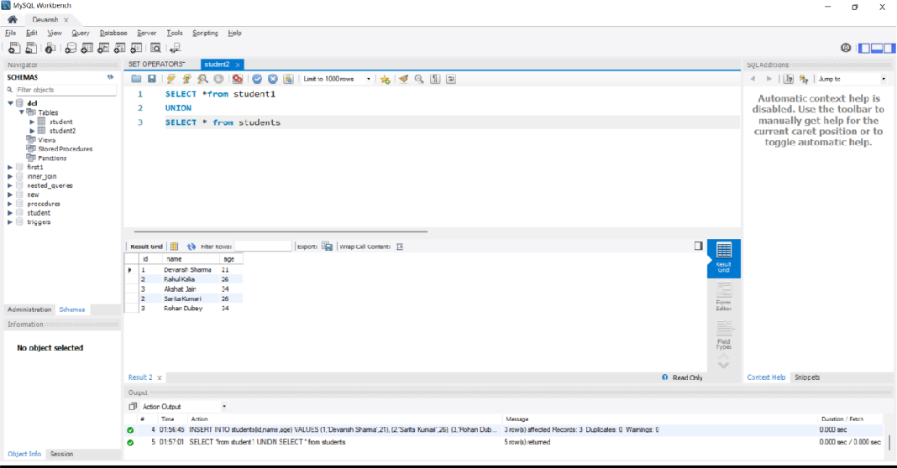

### Union All:-

SELECT *from student1 UNION ALL

SELECT * from students

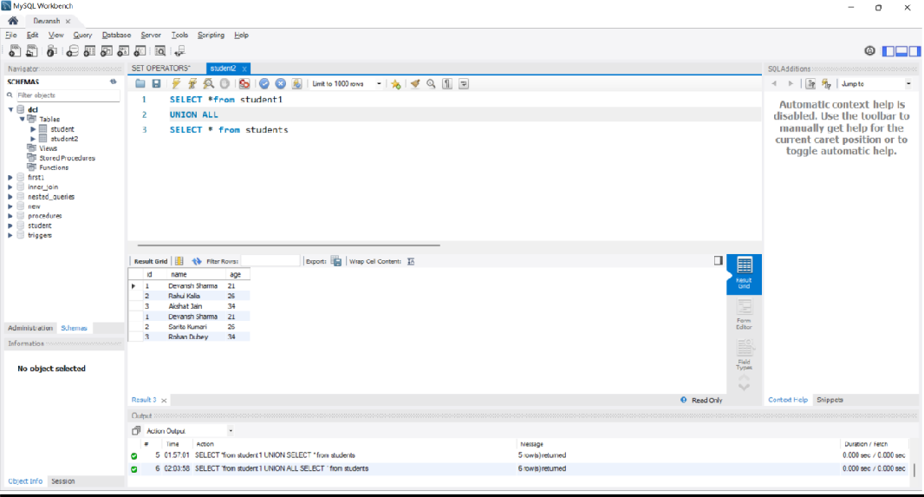

### INTERSECT:- Query:-

**FOR CREATING TABLE**

CREATE TABLE tab1 ( Id INT PRIMARY KEY

);

INSERT INTO tab1 VALUES (1), (2), (3), (4);

CREATE TABLE tab2 ( id INT PRIMARY KEY

);

INSERT INTO tab2 VALUES (3), (4), (5), (6);

### FOR EXECUTION

SELECT DISTINCT Id FROM tab1 INNER JOIN tab2 USING (Id);

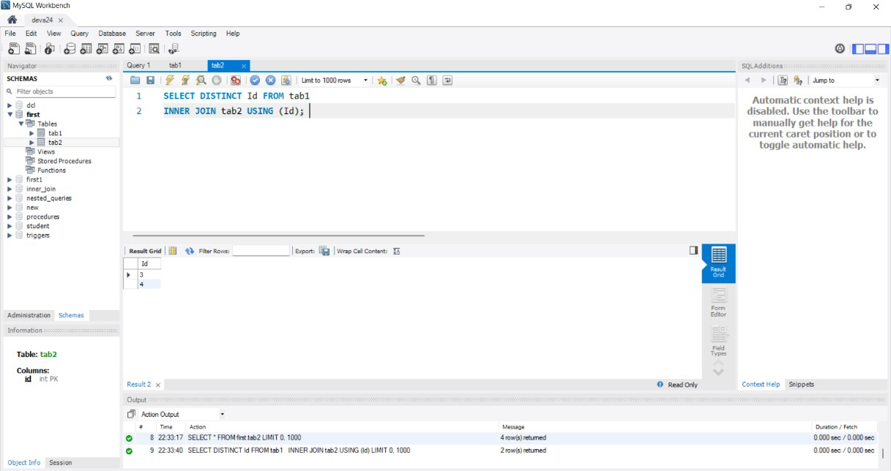

### MINUS:- Query:-

**FOR CREATING TABLE**

CREATE TABLE t1 (

id INT PRIMARY KEY

);

CREATE TABLE t2 (

id INT PRIMARY KEY

);

INSERT INTO t1 VALUES (1),(2),(3); INSERT INTO t2 VALUES (2),(3),(4);

### FOR EXECUTION

SELECT

id FROM

t1

LEFT JOIN

t2 USING (id) WHERE

t2.id IS NULL;

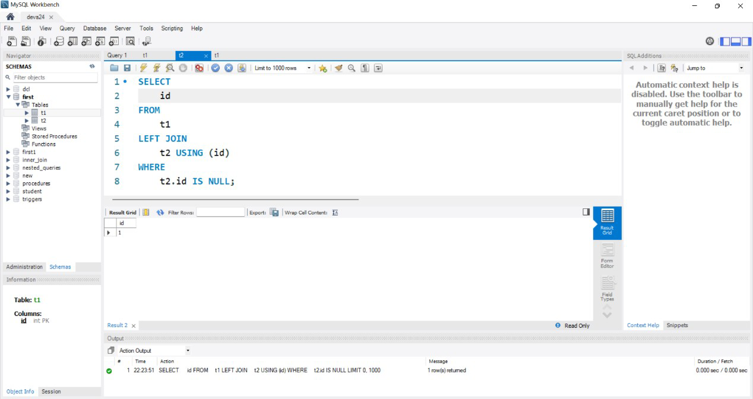

### VIEWS:-

**Theory:-**

In SQL, a view is a virtual table based on the result-set of an SQL statement.

A view contains rows and columns, just like a real table. The fields in a view are fields from one or more real tables in the database.

You can add SQL statements and functions to a view and present the data as if the data were coming from one single table.

A view is created with the CREATE VIEW statement.

### QUERY:-

CREATE VIEW student_data AS

SELECT s.id,s.name,c.city FROM student s

INNER JOIN City c

ON s.id= c.cid;

SELECT * FROM student_data

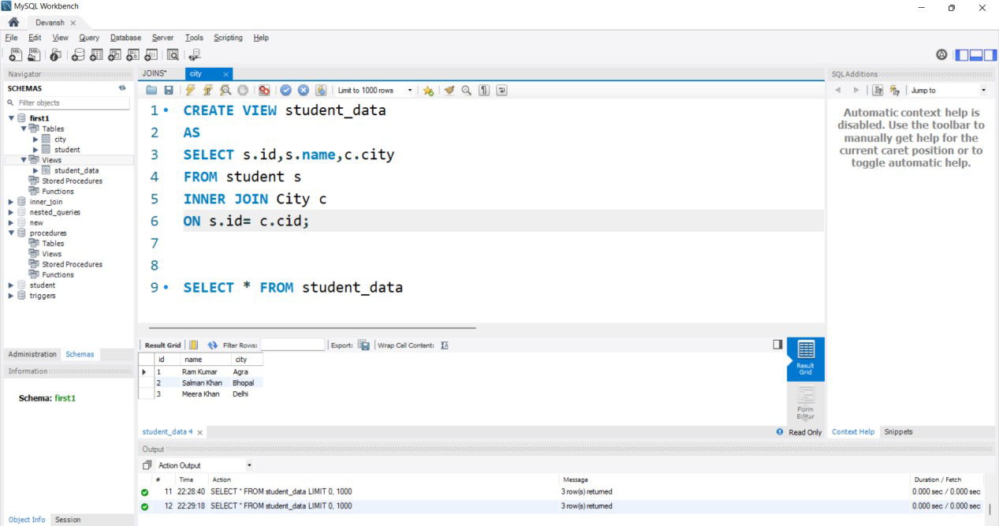

IF we rename the existing view then we use RENAME Command:- RENAME TABLE student_data

TO new_data;

SELECT * FROM new_data

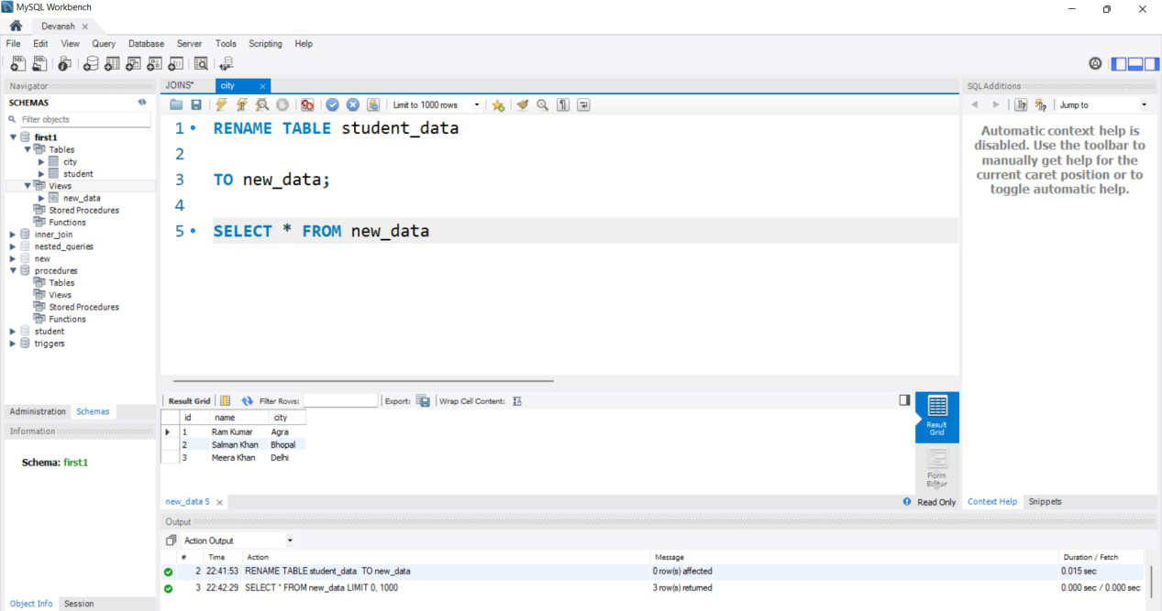

IF we DELETE the VIEW then we use DROP VIEW:-

### QUERY:-

DROP VIEW new_data;

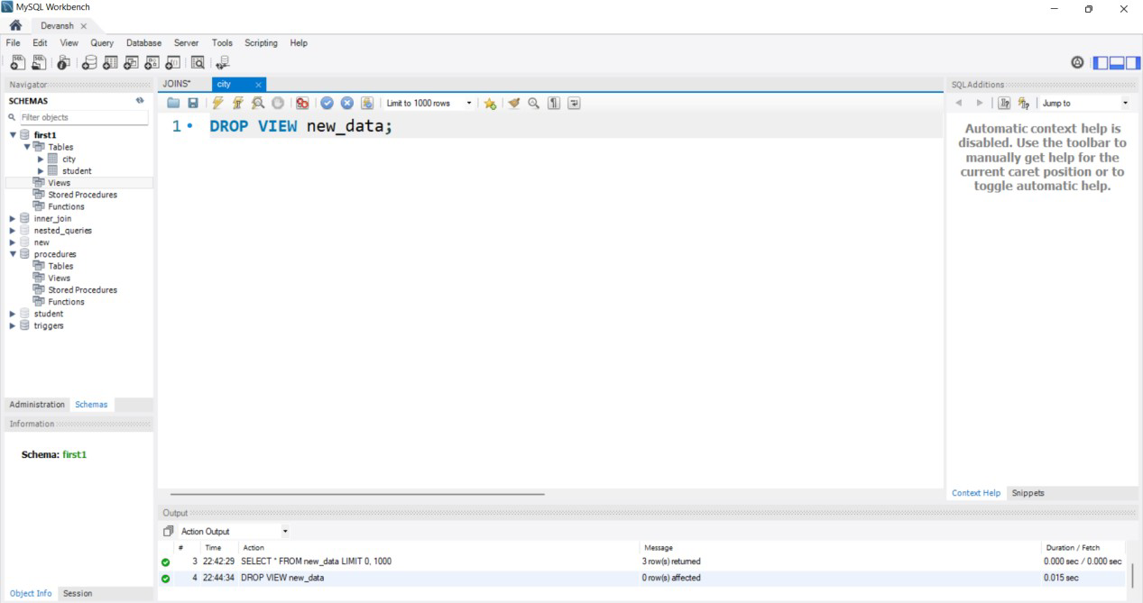

### ALTER IN VIEWS QUERY:-

ALTER VIEW data AS

SELECT * FROM student_table INNER JOIN City

ON student_table.city=City.cid WHERE age>22;

SELECT *from data;

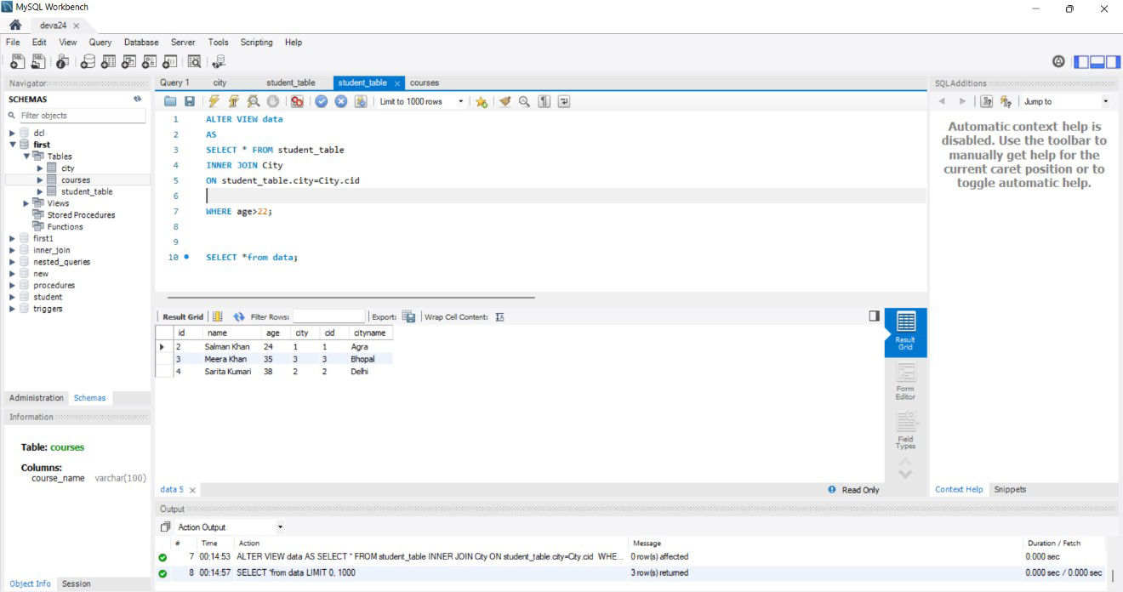

Exp No:-9 Date:-

# EXPERIMENT:-Conditional &Iterative Statements

**AIM –** PL/SQL conditional and iterative statements.

**Theory:-** A program that supports a user interface may run a main loop that waits for, and then processes, user keystrokes (this doesn’t apply to stored programs, however).Many mathematical algorithms can be implemented only by loops in computer programs.When processing a file, a program may loop through each record in the file and perform computations.A database program may loop through the rows returned by a SELECT statement.

**QUERY**

1. **Conditional Statement**

### FOR CREATING PROCEDURE

DELIMITER $$ CREATE PROCEDURE

GetCustomerLevel(

IN pCustomerNumber INT,

OUT pCustomerLevel VARCHAR(20)) BEGIN

DECLARE credit DECIMAL(10,2) DEFAULT 0;

SELECT creditLimit INTO credit FROM customers

WHERE customerNumber = pCustomerNumber;

IF credit > 50000 THEN

SET pCustomerLevel = 'PLATINUM'; END IF;

END$$ DELIMITER ;

### FOR EXECUTION

SELECT

customerNumber, creditLimit

FROM

customers WHERE

creditLimit > 50000 ORDER BY

creditLimit DESC;

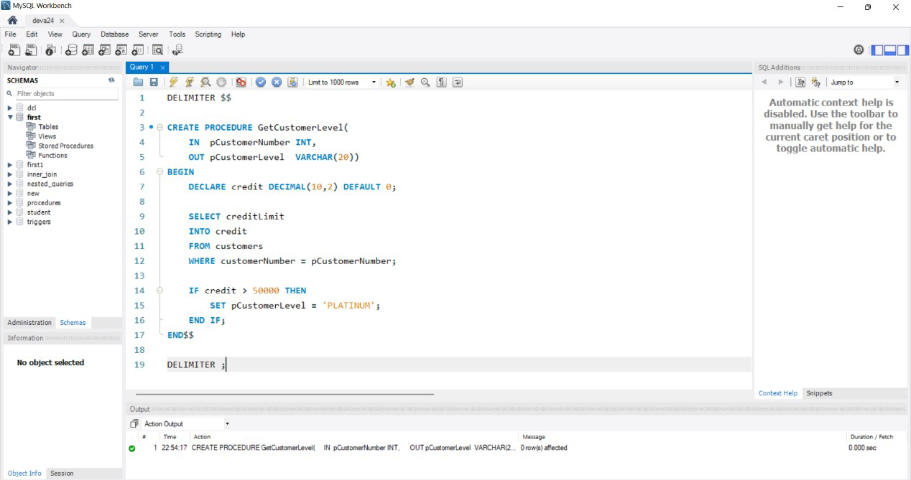

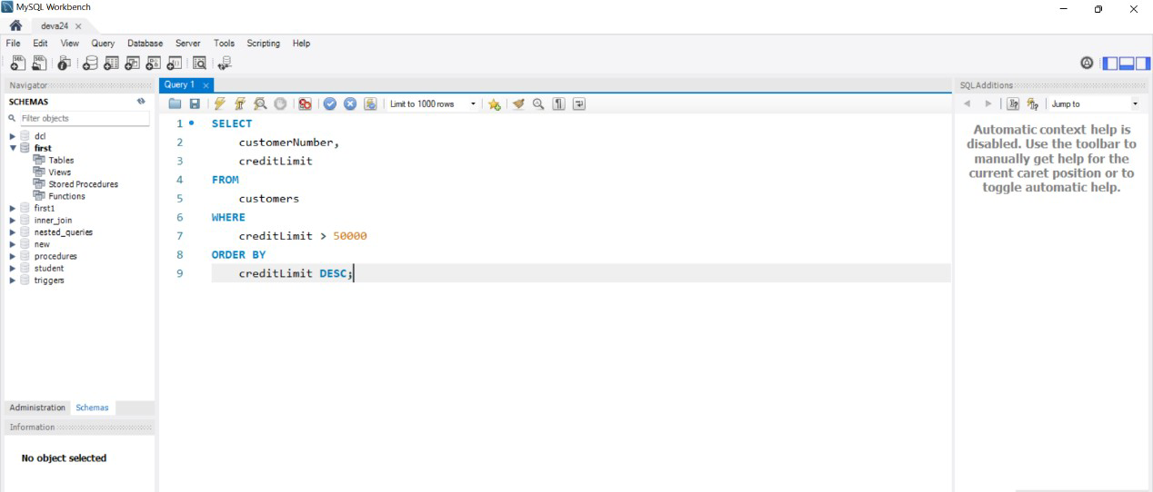

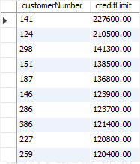

## Iterative Statement

CREATE TABLE calendars(

id INT AUTO_INCREMENT,

fulldate DATE UNIQUE, day TINYINT NOT NULL,

month TINYINT NOT NULL,

quarter TINYINT NOT NULL, year INT NOT NULL, PRIMARY KEY(id)

);

### FOR CREATING PROCEDURE

DELIMITER $$

CREATE PROCEDURE InsertCalendar(dt DATE)

BEGIN

INSERT INTO calendars( fulldate,

day, month, quarter, year

) VALUES(

dt,

EXTRACT(DAY FROM dt), EXTRACT(MONTH FROM dt), EXTRACT(QUARTER FROM dt), EXTRACT(YEAR FROM dt)

);

END$$ DELIMITER ;

DELIMITER $$

CREATE PROCEDURE LoadCalendars( startDate DATE,

day INT

) BEGIN

DECLARE counter INT DEFAULT 1;

DECLARE dt DATE DEFAULT

startDate;

WHILE counter <= day DO CALL InsertCalendar(dt); SET counter = counter + 1; SET dt =

DATE_ADD(dt,INTERVAL 1 day); END WHILE;

END$$ DELIMITER ;

### FOR EXECUTION

CALL LoadCalendars('2019-01-01',31);

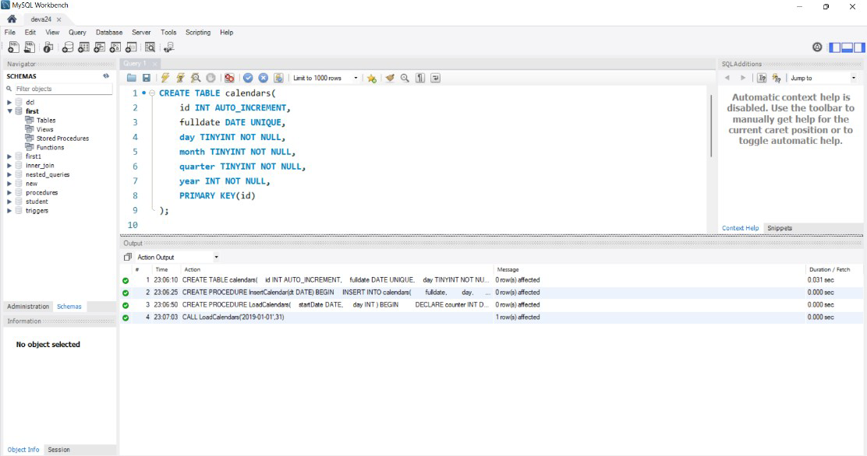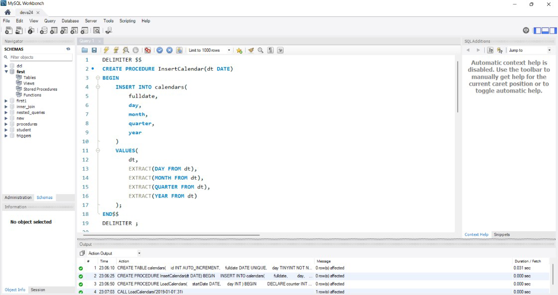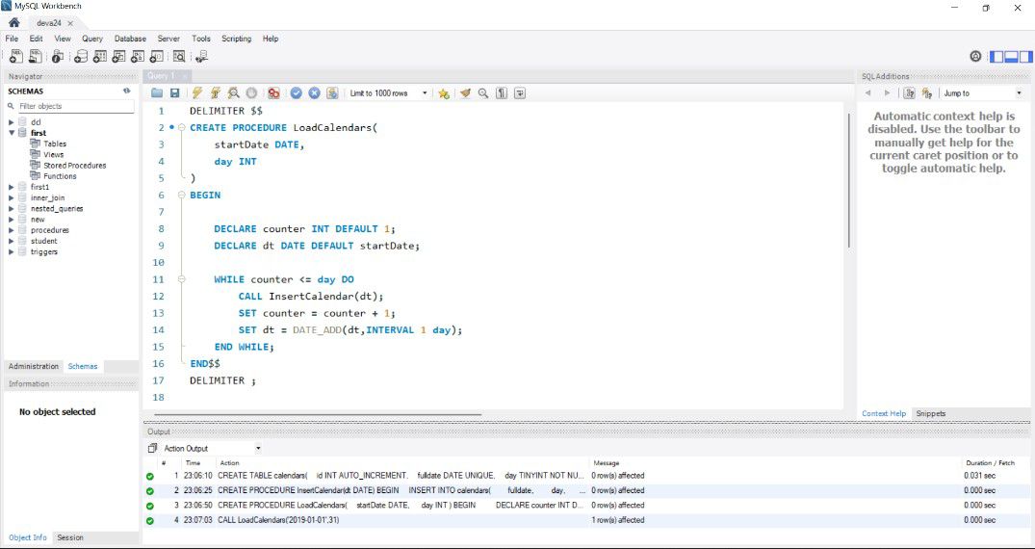

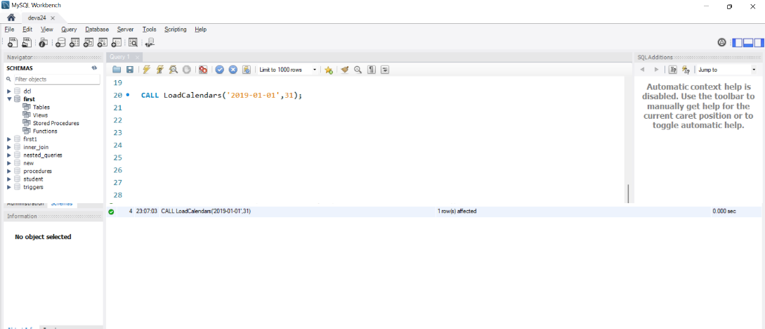

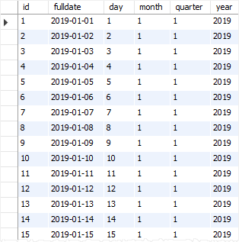

Exp No:-10 Date:-

# EXPERIMENT:-Procedures

**Aim:-** To Execute Procedure in MySql

**Theory:-** A procedure (often called a stored procedure) is a collection of pre- compiled SQL statements stored inside the database. It is a subroutine or a subprogram in the regular computing language. A procedure always contains a name, parameter lists, and SQL statements. We can invoke the procedures by using triggers, other procedures and applications such as [Java](https://www.javatpoint.com/java-tutorial), [Python,](https://www.javatpoint.com/python-tutorial) [PHP](https://www.javatpoint.com/php-tutorial), etc. It was first introduced in MySQL version 5. Presently, it can be supported by almost all relational database systems.

If we consider the enterprise application, we always need to perform specific tasks such as database cleanup, processing payroll, and many more on the database regularly. Such tasks involve multiple [SQL](https://www.javatpoint.com/sql-tutorial) statements for executing each task. This process might easy if we group these tasks into a single task. We can fulfill this requirement in [MySQL](https://www.javatpoint.com/mysql-tutorial) by creating a stored procedure in our database.

### Query:-

create table film(rating int ,name varchar(20),release_date int); insert into film values(4,'tomandJerry',90);

insert into film values(5,'harrypotter',21); insert into film values(2,'jamesBond',85); insert into film values(3,'jumanji',22);

DELIMITER //

CREATE PROCEDURE sp_GetMovies() BEGIN

select rating,name,release_date from film; END //

DELIMITER ;

CALL sp_GetMovies();

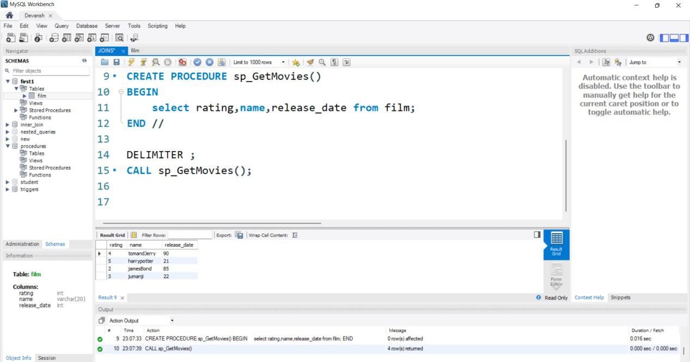

Exp No:-11 Date:-

# EXPERIMENT:-PL/SQL Functions

**AIM -** PL/SQL functions

**Theory**:- A function can be used as a part of SQL expression i.e. we can use them with select/update/merge commands. One most important characteristic of a function is that unlike procedures, it must return a value.

### QUERY

**CREATING TABLE FOR FUNCTION**

CREATE TABLE employee( emp_id INT,

fname varchar(50), lname varchar(50), start_date date

);

INSERT INTO

employee(emp_id,fname,lname,start_date) VALUES

(1,'Michael','Smith','2001-06-22'),

(2,'Susan', 'Barker','2002-09-12'),

(3,'Robert','Tvler','2000-02-09'),

(4,'Susan','Hawthorne','2002-04-24');

### CREATING FUNCTION

DELIMITER //

CREATE FUNCTION no_of_years(date1 date) RETURNS int DETERMINISTIC BEGIN

DECLARE date2 DATE;

Select current_date()into date2; RETURN year(date2)-year(date1); END //

DELIMITER ;

**CALLING FUNCTION**

Select emp_id, fname, lname, no_of_years(start_date) as 'years' from employee;

**OUTPUT:-**

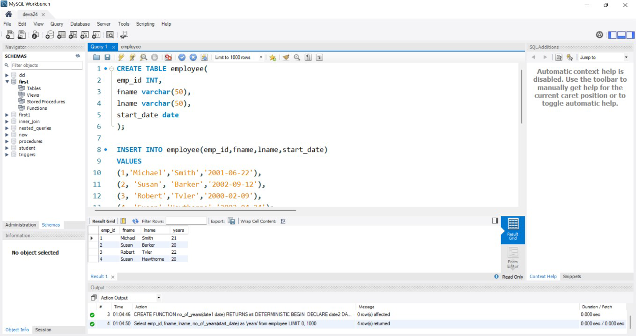

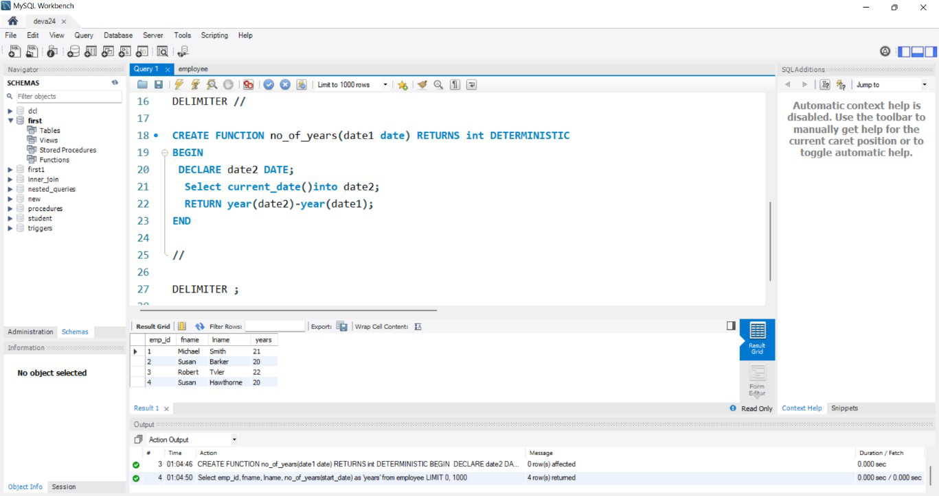

Exp No:-12 Date:-

**EXPERIMENT:-PL/SQL Cursors**

**Aim:-** To Execute Cursors in MySql

**Theory:-** A cursor allows you to iterate a set of rows returned by a query and process each row individually. MySQL cursor is read-only, non-scrollable and asensitive.

Read-only: you cannot update data in the underlying table through the cursor.

### QUERY:-

CREATE TABLE GetVatsaCursor(

C_ID INT PRIMARY KEY AUTO_INCREMENT,

c_name VARCHAR(50), c_address VARCHAR(200)); CREATE TABLE Vbackupdata( C_ID INT,

c_name VARCHAR(50), c_address VARCHAR(200));

INSERT INTO GetVatsaCursor(c_name, c_address) VALUES('Test', '132, Vatsa Colony'),

('Admin', '133, Vatsa Colony'),

('Vatsa', '134, Vatsa Colony'),

('Onkar', '135, Vatsa Colony'),

('Rohit', '136, Vatsa Colony'),

('Simran', '137, Vatsa Colony'), ('Jashmin', '138, Vatsa Colony'), ('Anamika', '139, Vatsa Colony'), ('Radhika', '140, Vatsa Colony'); SELECT * FROM GetVatsaCursor; SELECT * FROM Vbackupdata; delimiter //

CREATE PROCEDURE firstCurs() BEGIN

DECLARE d INT DEFAULT 0; DECLARE c_id INT;

DECLARE c_name, c_address VARCHAR(20);

DECLARE Get_cur CURSOR FOR SELECT * FROM GetVatsaCursor; DECLARE CONTINUE HANDLER FOR SQLSTATE '02000'

SET d = 1;

DECLARE CONTINUE HANDLER FOR SQLSTATE '23000' SET d = 1;

OPEN Get_cur; lbl: LOOP

IF d = 1 THEN

LEAVE lbl;

END IF;

IF NOT d = 1 THEN

FETCH Get_cur INTO c_id, c_name, c_address;

INSERT INTO Vbackupdata VALUES(c_id, c_name, c_address); END IF;

END LOOP;

CLOSE Get_cur;

END;

CALL firstCurs();

SELECT * FROM Vbackupdata

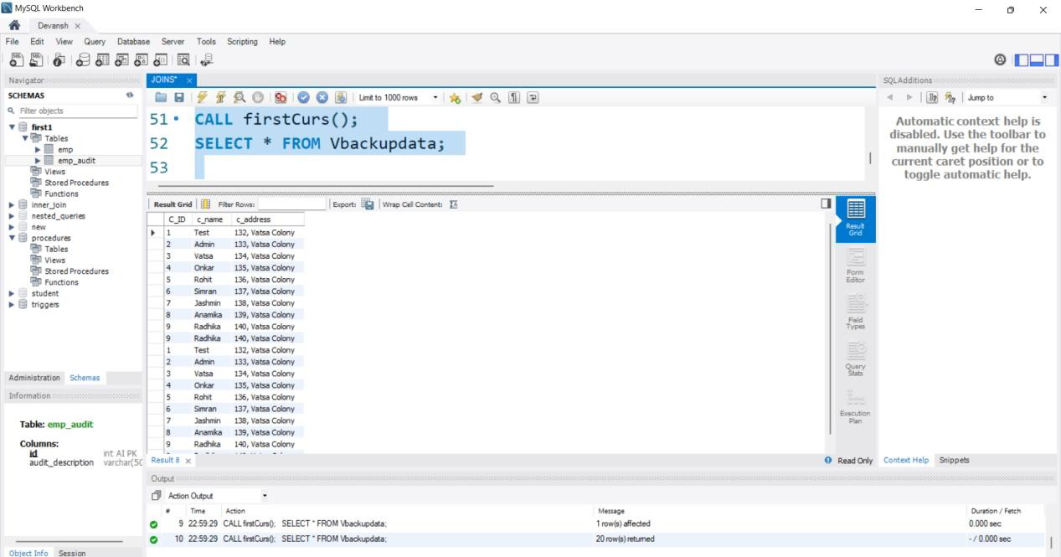

Exp No:-13 Date:-

# EXPERIMENT:-PL/SQL Exception Handling

**Aim-** PL/SQL exception handling.

**Theory**:-When an error occurs inside a stored procedure, it is important to handle it appropriately, such as continuing or exiting the current code block’s execution, and issuing a meaningful error message.MySQL provides an easy way to define handlers that handle from general conditions such as warnings or exceptions to specific conditions e.g., specific error codes.

### QUERY:-

DROP PROCEDURE IF EXISTS InsertSupplierProduct; DELIMITER $$

CREATE PROCEDURE InsertSupplierProduct( IN inSupplierId INT,

IN inProductId INT

)

BEGIN

-- exit if the duplicate key occurs

DECLARE EXIT HANDLER FOR 1062 SELECT

'Duplicate keys error encountered' Message; DECLARE EXIT HANDLER FOR SQLEXCEPTION

SELECT 'SQLException encountered' Message; DECLARE EXIT HANDLER FOR SQLSTATE '23000' SELECT 'SQLSTATE 23000' ErrorCode;

-- insert a new row into the SupplierProducts

INSERT INTO SupplierProducts(supplierId,productId) VALUES(inSupplierId,inProductId);

-- return the products supplied by the supplier id SELECT COUNT(*)

FROM SupplierProducts

WHERE supplierId = inSupplierId; END$$

DELIMITER ;

**OUTPUT**

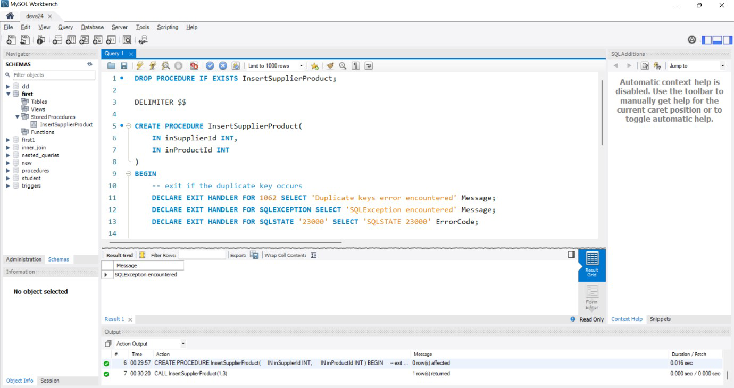

Exp No:-14 Date:-

# EXPERIMENT:-PL/SQL Trigger

**Aim:-** To Execute Triggers in MYsql

**Theory:-** A trigger in MySQL is a set of SQL statements that reside in a system catalog. It is a special type of stored procedure that is invoked automatically in response to an event. Each trigger is associated with a table, which is activated on any DML statement such as INSERT, UPDATE, or DELETE.

A trigger is called a special procedure because it cannot be called directly like a stored procedure. The main difference between the trigger and procedure is that a trigger is called automatically when a data modification event is made against a table. In contrast, a stored procedure must be called explicitly.

### QUERY:-

CREATE TABLE emp(

id INT PRIMARY KEY AUTO_INCREMENT, name VARCHAR(50),

age INT

);

CREATE TABLE emp_audit(

id INT PRIMARY KEY AUTO_INCREMENT,

audit_description VARCHAR(500)

);

DELIMITER //

CREATE TRIGGER tr_AfterInsetEmp AFTER INSERT

ON emp

FOR EACH ROW BEGIN

INSERT INTO emp_audit

VALUES(null,concat('newrow',date_format(now(),'%d-%m-%y %h:%i:%s %p'))); END//

DELIMITER ; INSERT INTO emp VALUES

(null,'Akash',22),

(null,'Devansh',18),

(null,'Akshat',21),

(null,'Rahul',24);

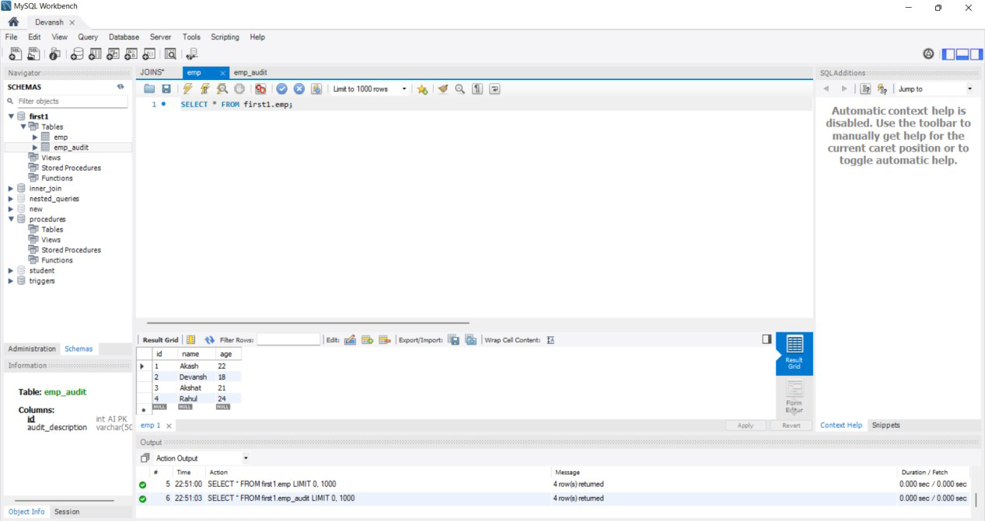

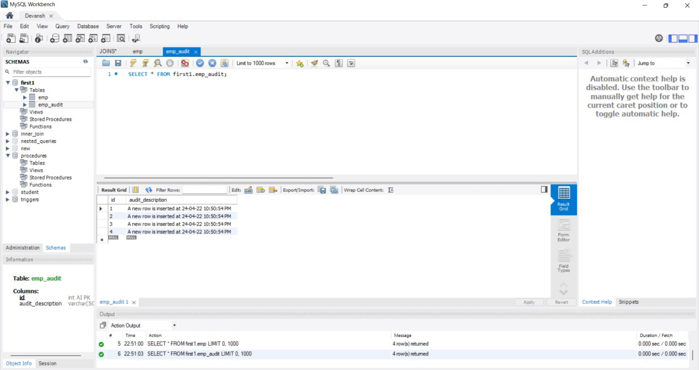

Exp No:-15 Date:-

# Experiment:-Frame And Execute PL/SQL Cursor & Exceptional Handling

**AIM –**Frame and execute all queries for a project: Home renting system database

**INTRODUCTION:-**The Home Rental System is Searching in Based on the Apartment House for rent in metropolitan cities. The Home Rental System is Based on the Owners and the Customers. The Owner is updated on the Apartment details, and rent details. The Customer is details about the Room space, Room rent and the Address Details also.

### PROBLEM STATEMENT

There is no properly allocate home and the system is not easily arranges according to their user interest. And also the home rental management system almost is done through the manual system.

The administrative system doesn’t have the facility to make home rental

management system through online and the most time the work done through illegal intermediate personwithout awareness of the administrative and this make more complex and more cost to find home for the customer. This leads to customer in to more trouble, cost, dishonest and time wastage.



Theproblemfoundinthe currentsystem:

moretedious.

Thesystem needsmorehuman power.

### OBJECTIVE

The main objective of the system is to develop online home rental management system for wolkite city

### Specific objectives

In order to attain the general objective, the following are the list of specific objectives:

* To facilitate home record keeping for who wants home and for administrative management system.
* Prepare an online home rental system for the home finders
* To reduce the travel costs and other unnecessary expenses of the buyer.
* Reduce the role of the broker, thus, providing protection from frauds related to papers.

### MODULES

* Tenant
* Owner
* Contract
* Payment

### OPERATION

* First will be the login page where the User will login using their ID and Password.
* Next the user will enter the details like the requirements of the house he needs and contact details
* The other ebd user who wants to rent their house can also give their details
* He can also search the houses available in a particular area.
* Whoever has the required spcifications of the house can contact using the details provided.
* There is also a chatting option if they want to communicate with each other. There is also an option of video calling.
* After providing the details in the website, a contract will be generated which they can download.

### OUTPUT:-

1. **Cursor Output**

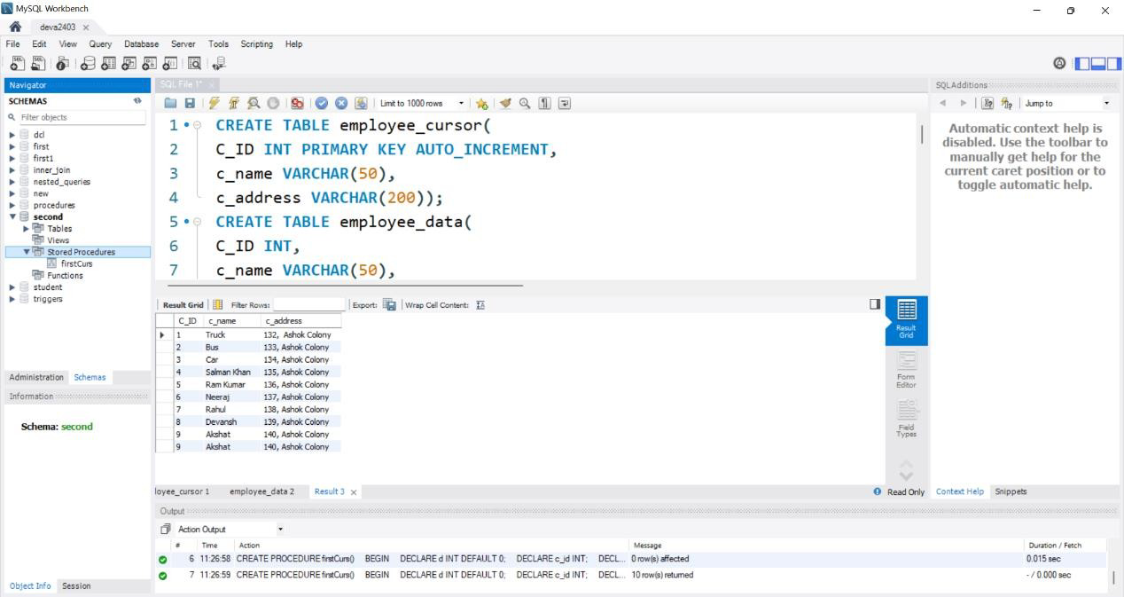

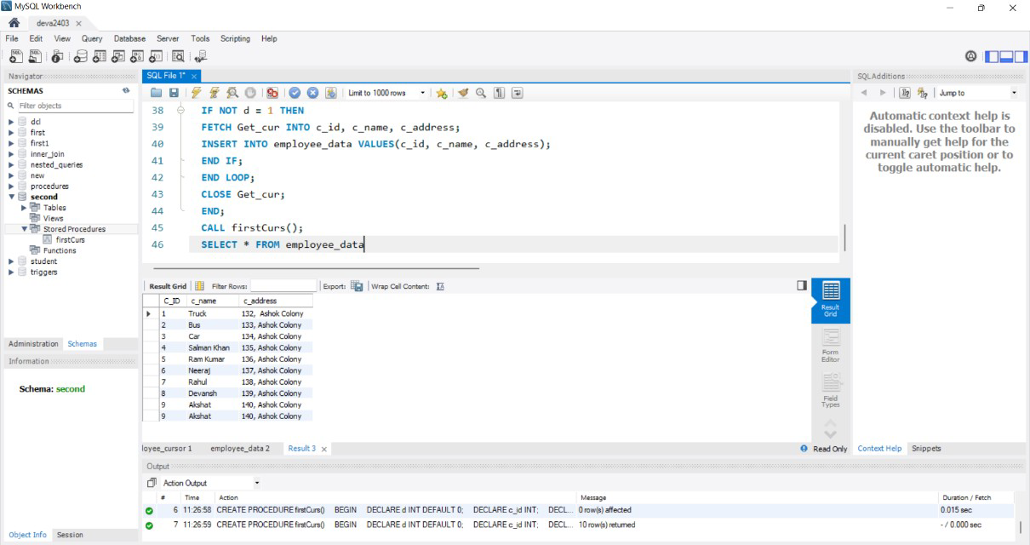

### Exception Handling

